Steps to create HDI container in BAS

1] Clone the repository from git
Go to azure
Select the repository of the use case that has been created
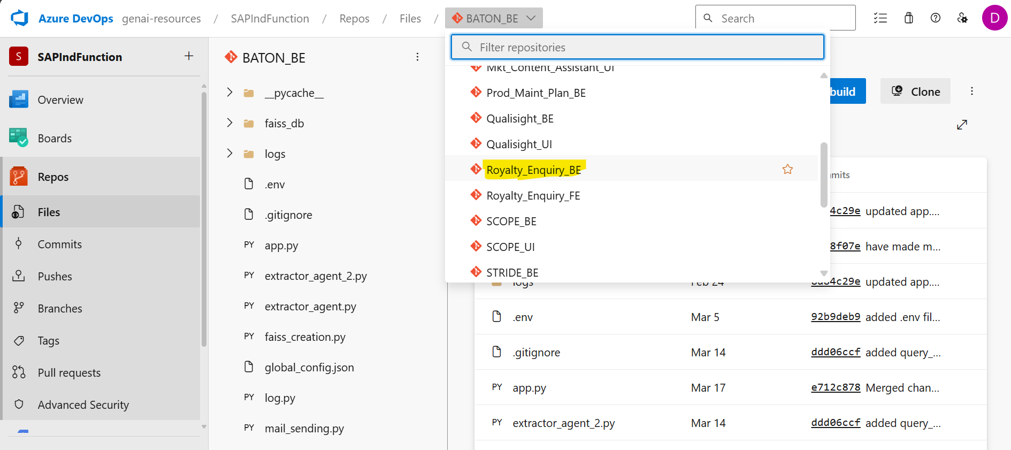
Select the release01 branch and then click on clone
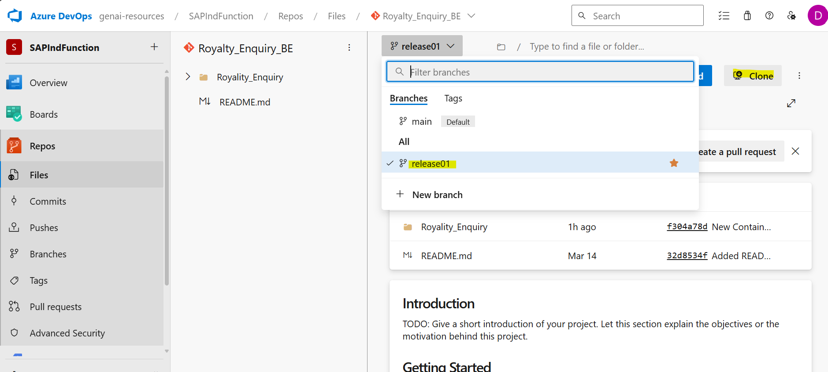

Copy the URL and go to BAS to clone the branch and generate git credentials for cloning
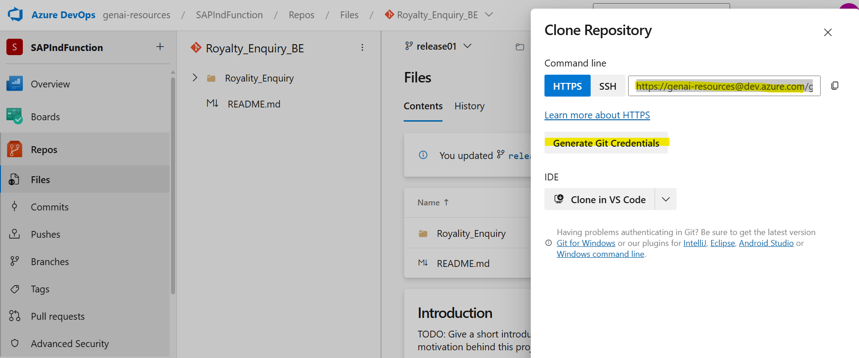

From BAS under projects, open a terminal and provide the below CLI command
git clone “URL copied”
It will ask for the username and password, get it from azure
If prompted for save for future use, select the same
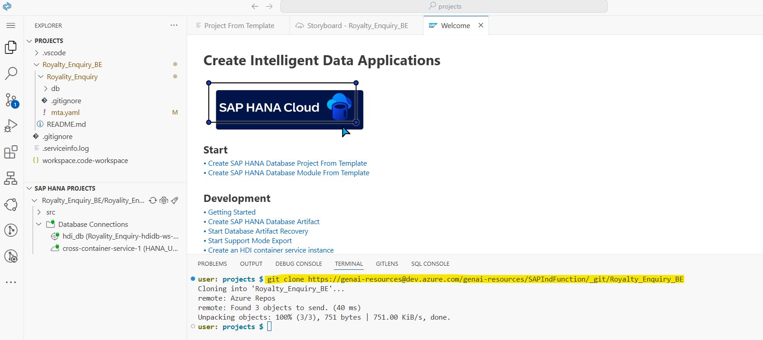

2] In BAS, change the repository to release 01 if it is main
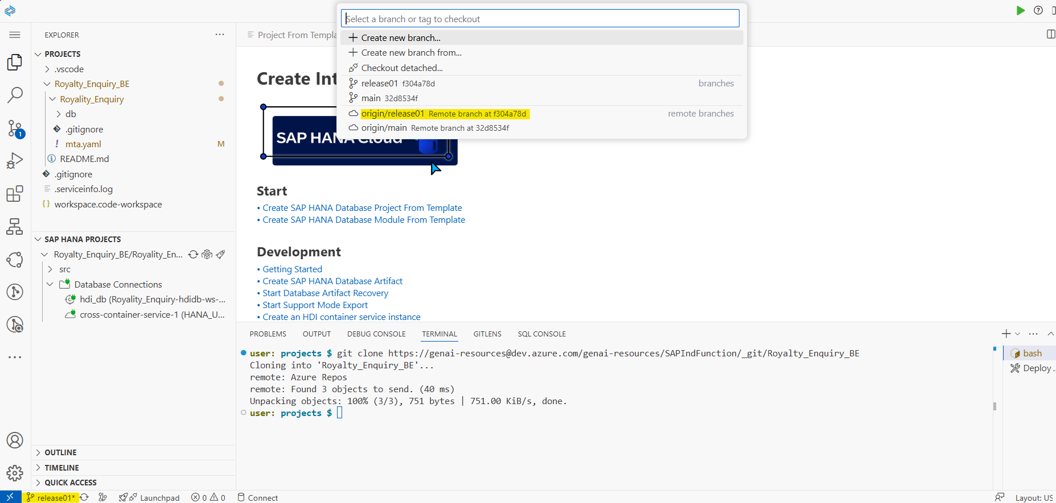

3] Create an SAP HANA DB Project from template
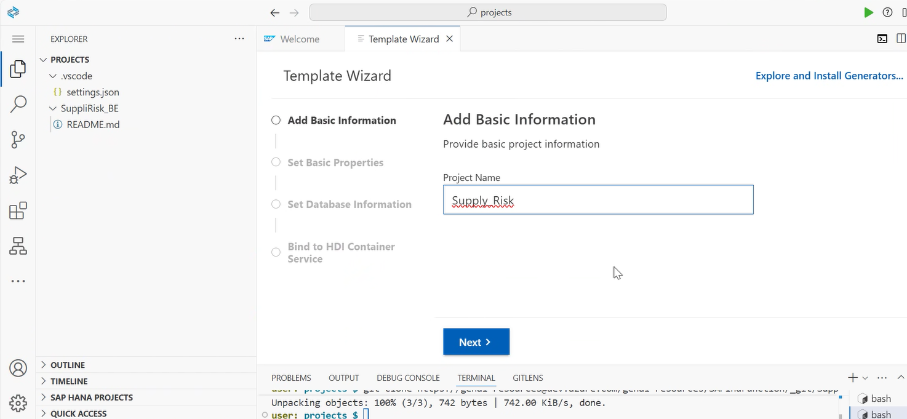
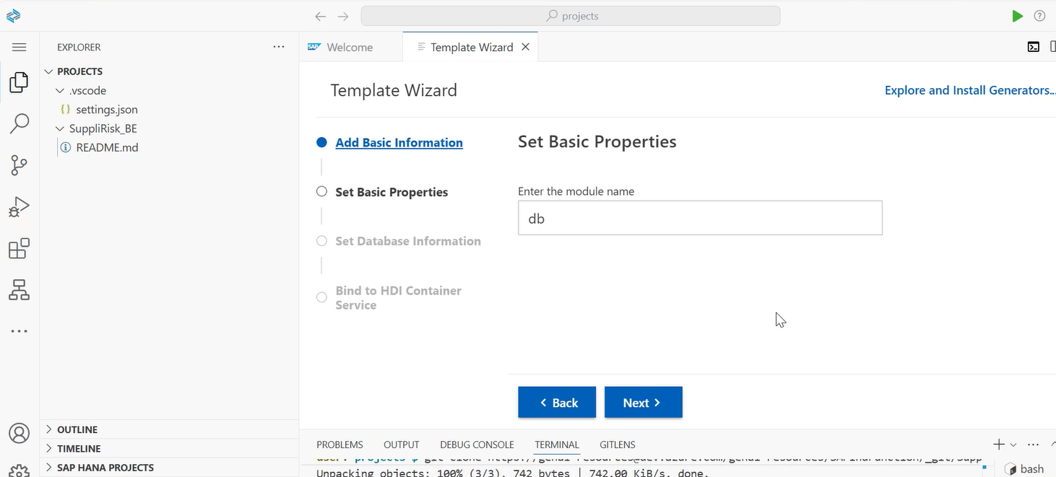
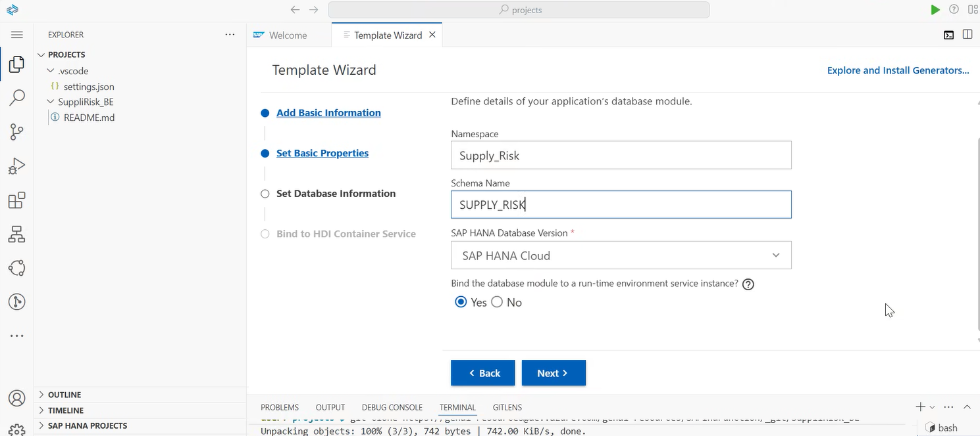
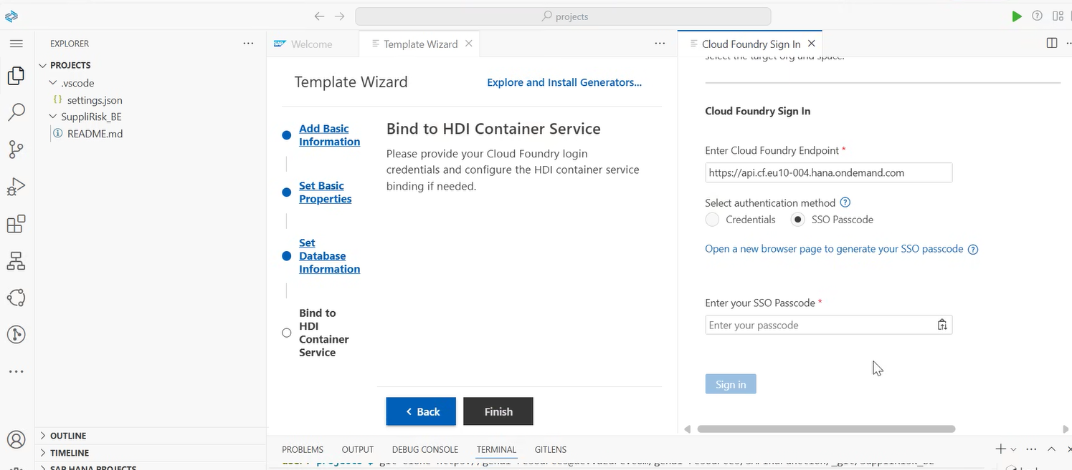
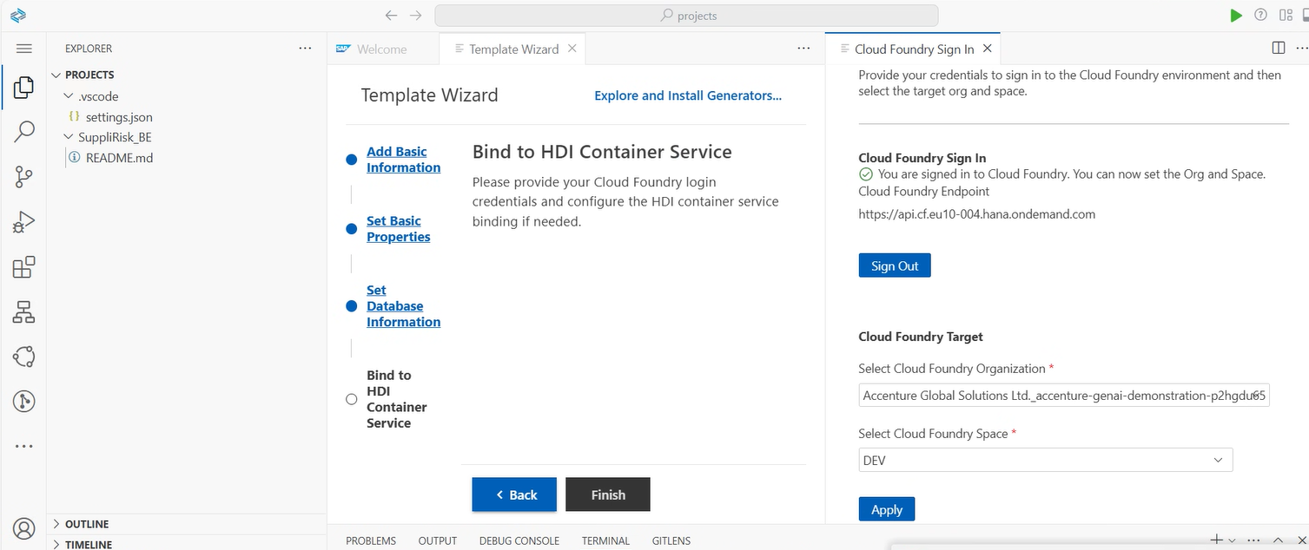
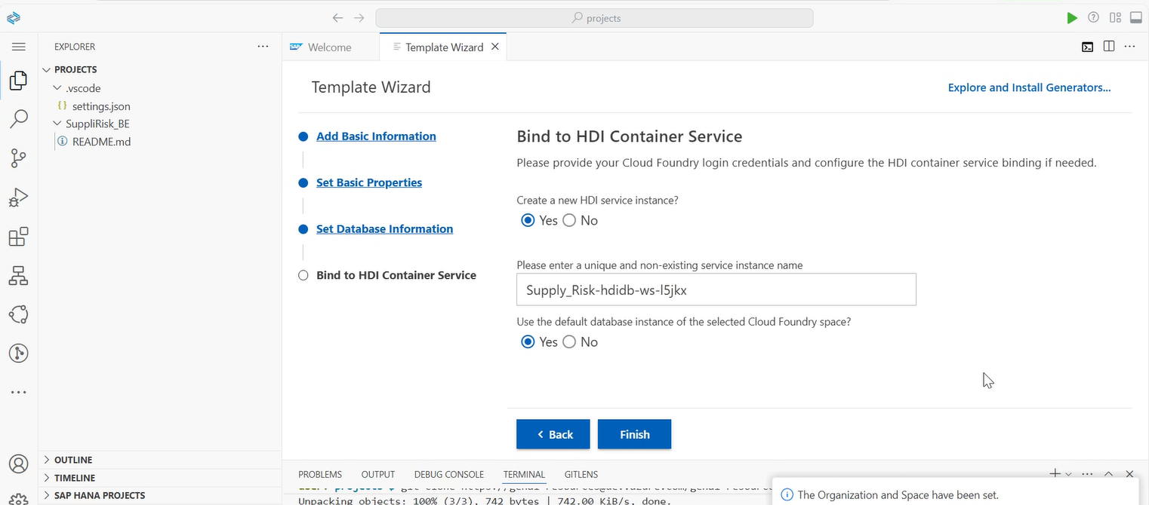
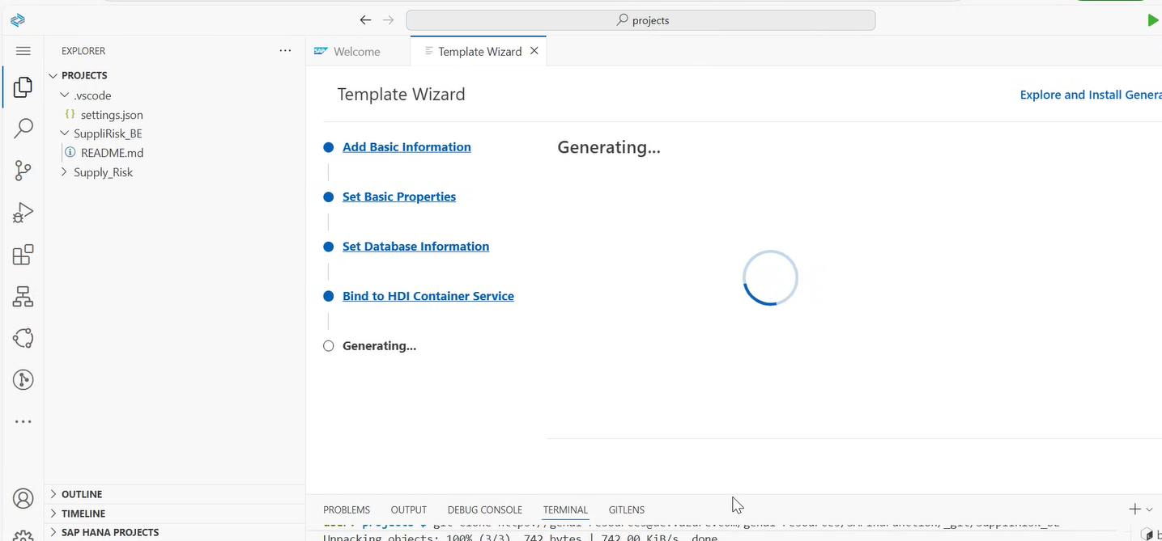
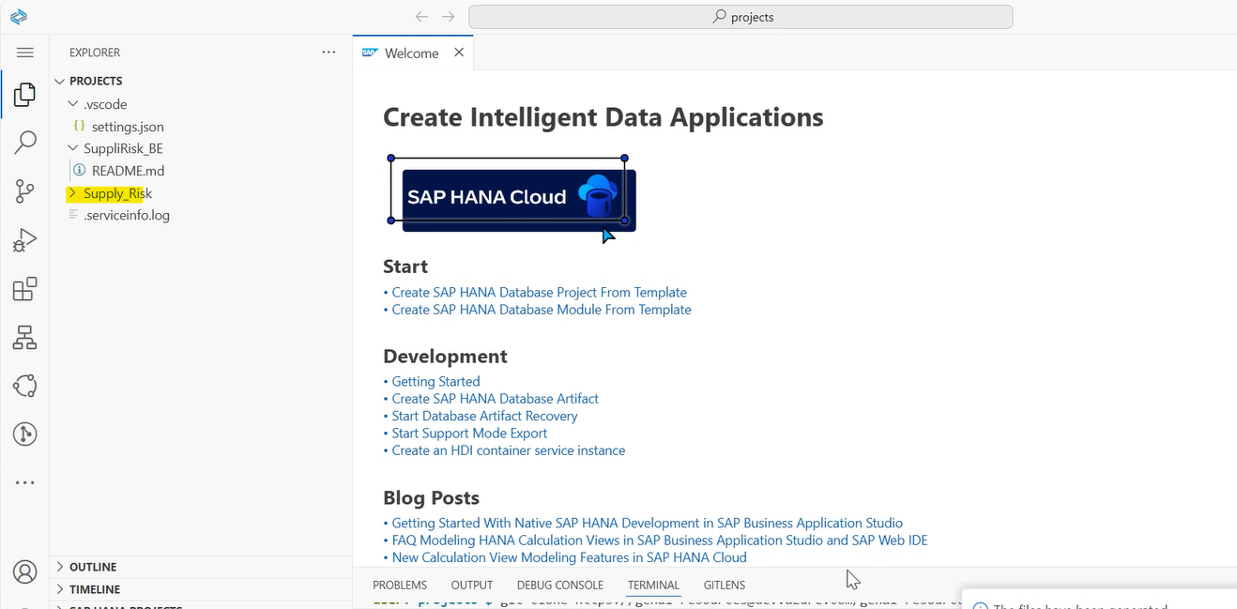
Once the project is generated, open the mta.yaml file and check for the schema name
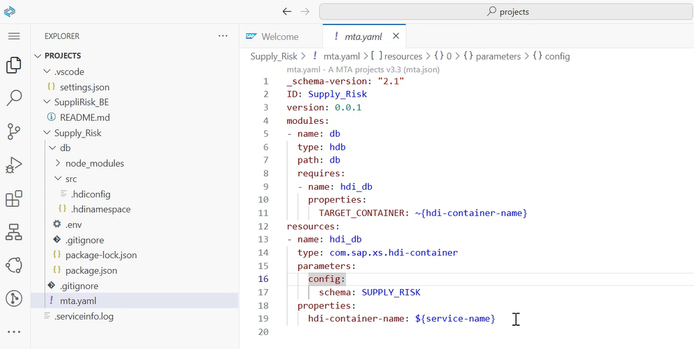

If schema name is provided correctly then add the below statement under config
makeUniqueName: False
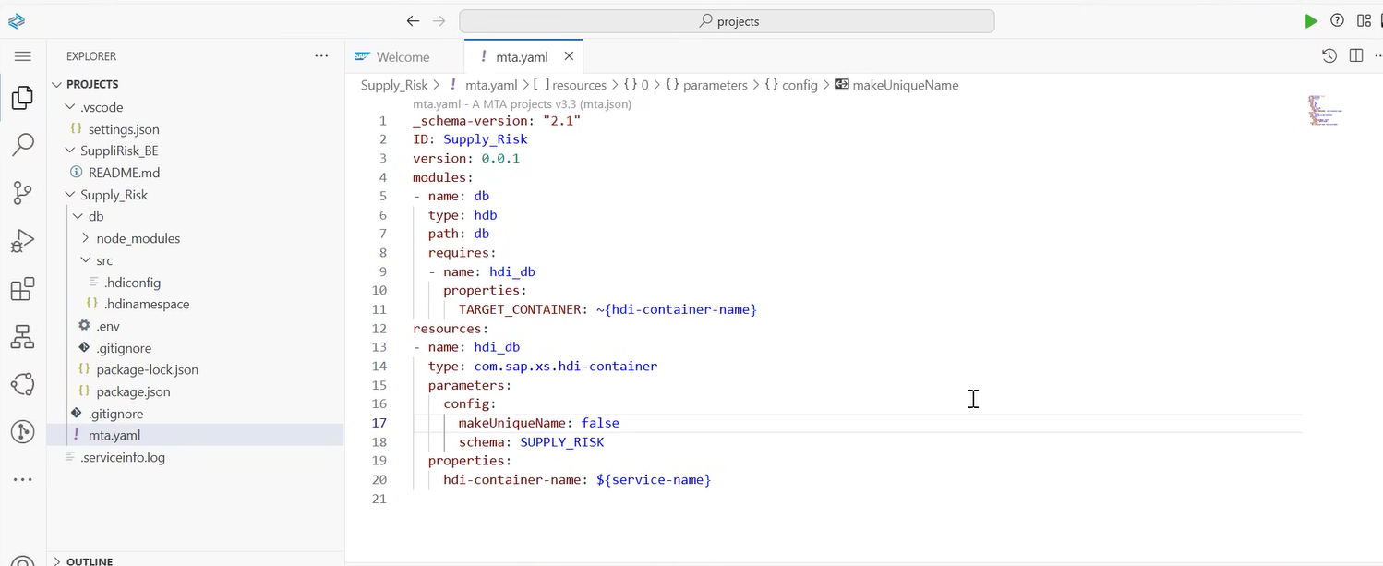

4] Sync up the projects
Drag and drop the new project into the main repository project
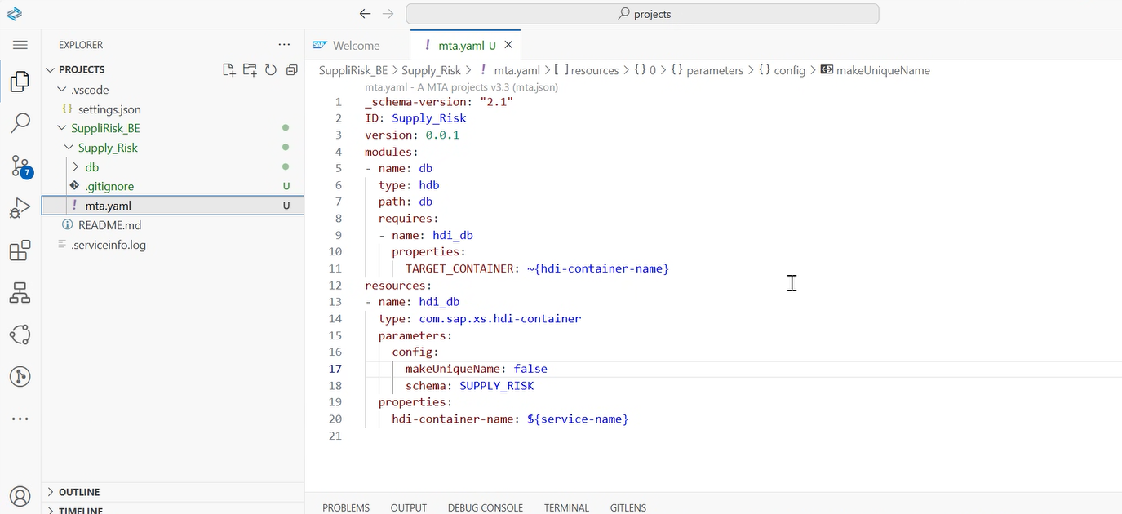

5] Staging all changes and committing to git
Go to git
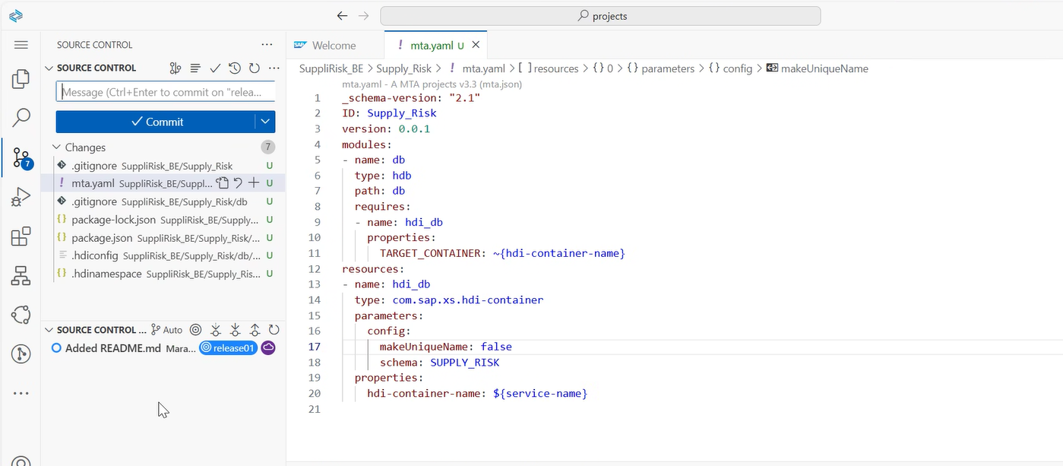

Over changes, select the option to stage all changes
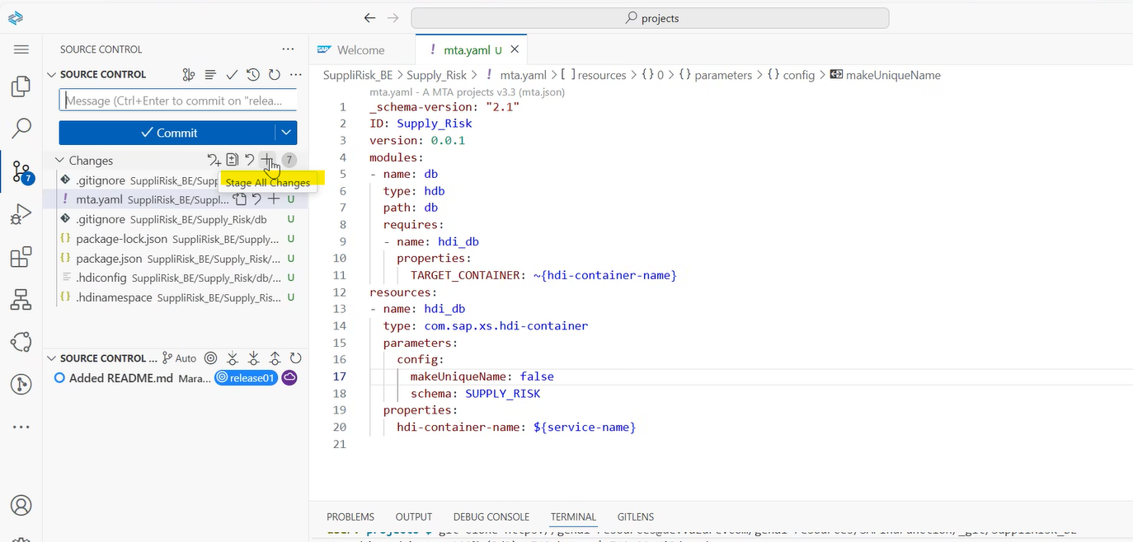
Once staging is done, provide a commit statement and click on commit
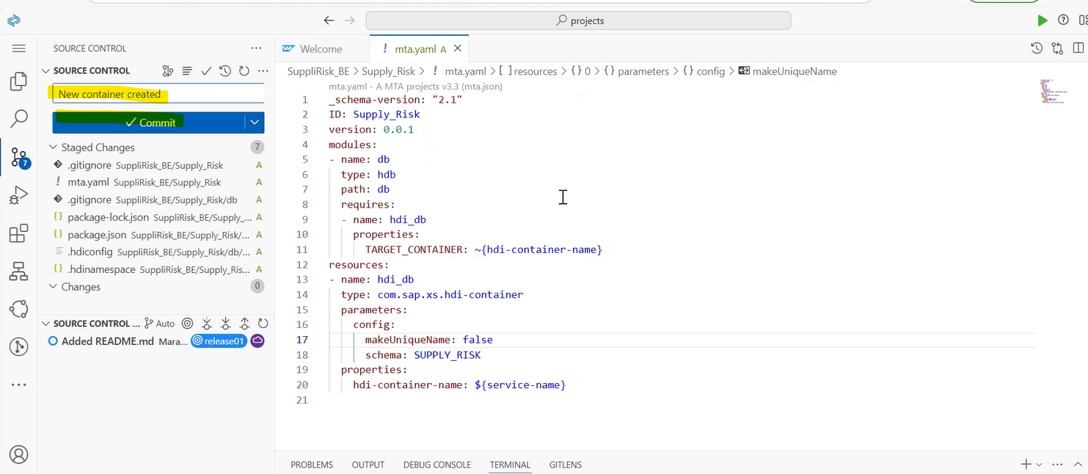

Click on Sync changes, to sync it with the git
Under source control, we can see that a new container has been created
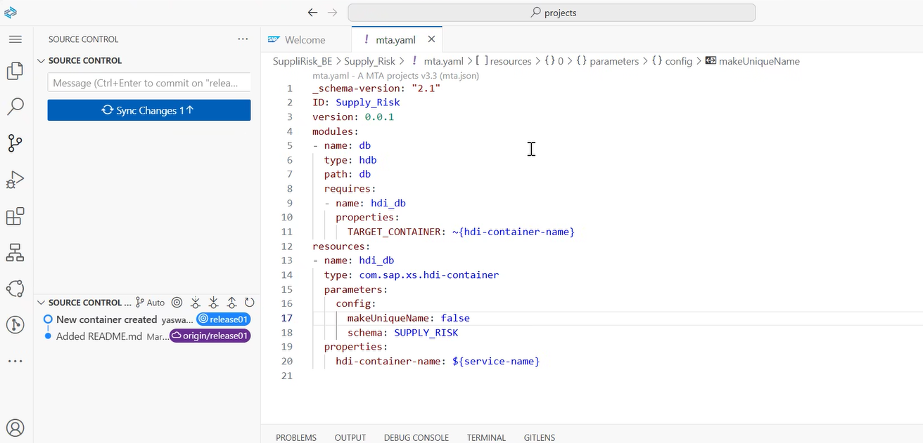

6] Project deployment
Once the changes have been merged with git, to deploy the project bind the hdi container if not binded already
Add a new DB connection
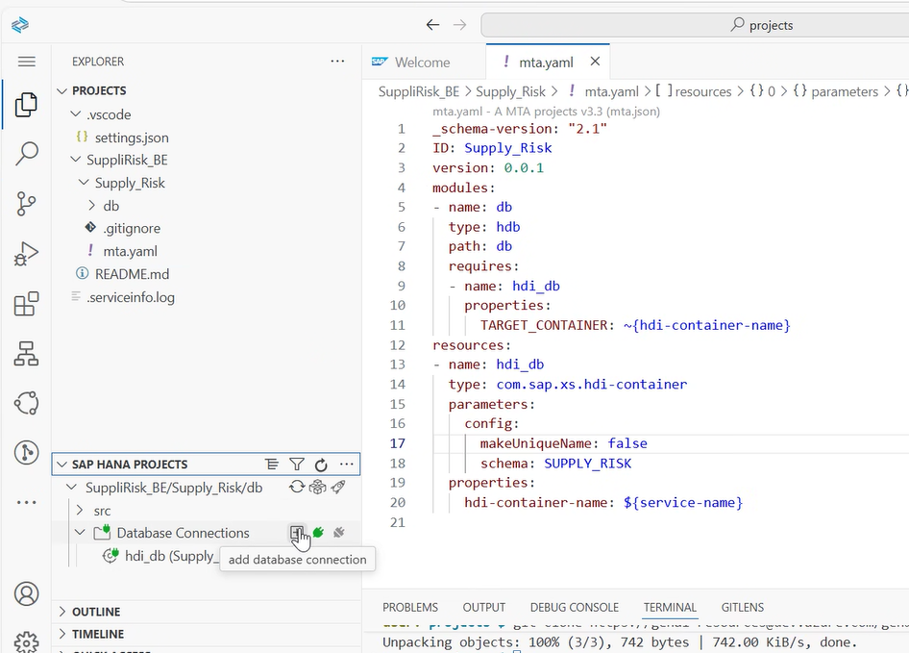

Choose the connection type as existing user provided service instance
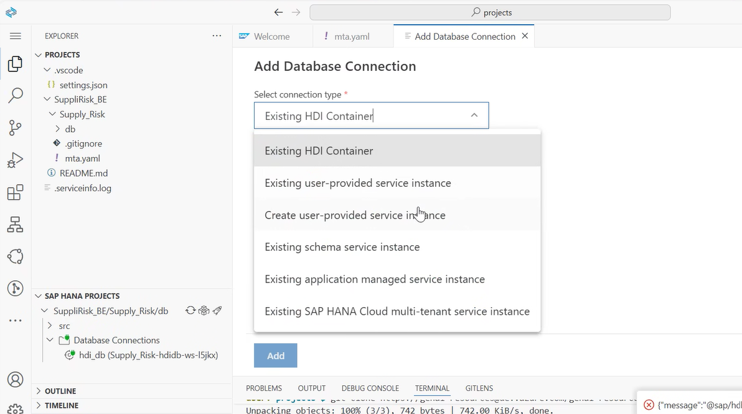
Select the isntance name as HANA_UPS
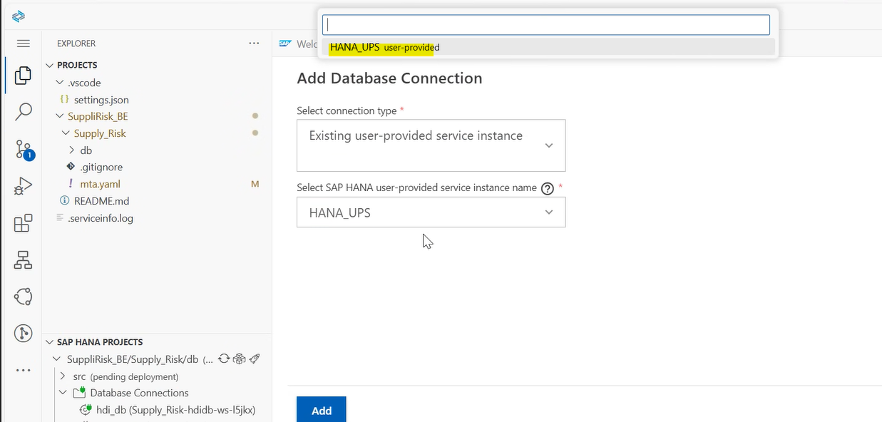

Once a connection is created, bind it
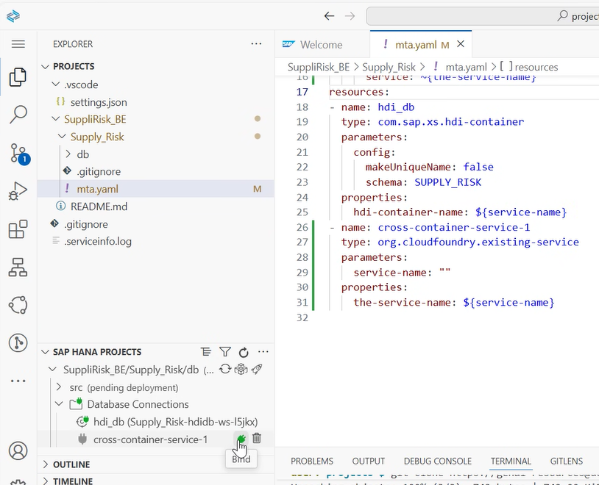
Bind to a user provided service
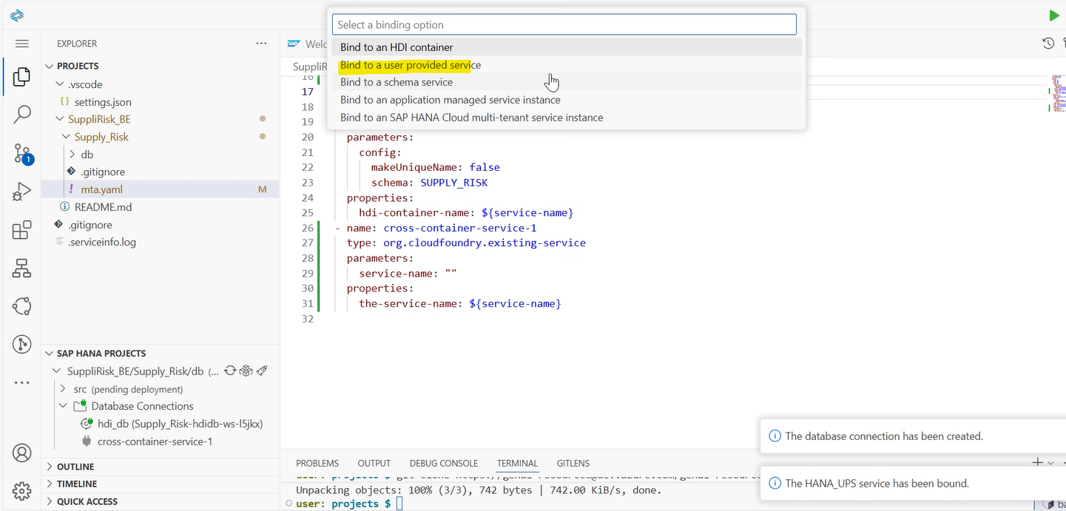
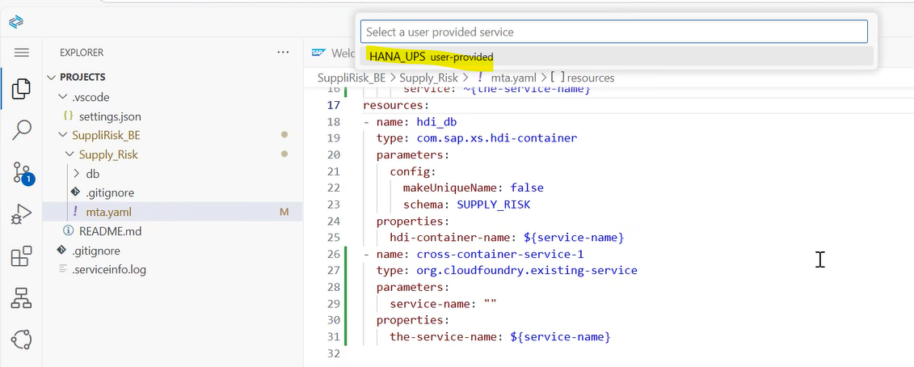
Once done, deploy the project. Once deployed get the generated container schema name
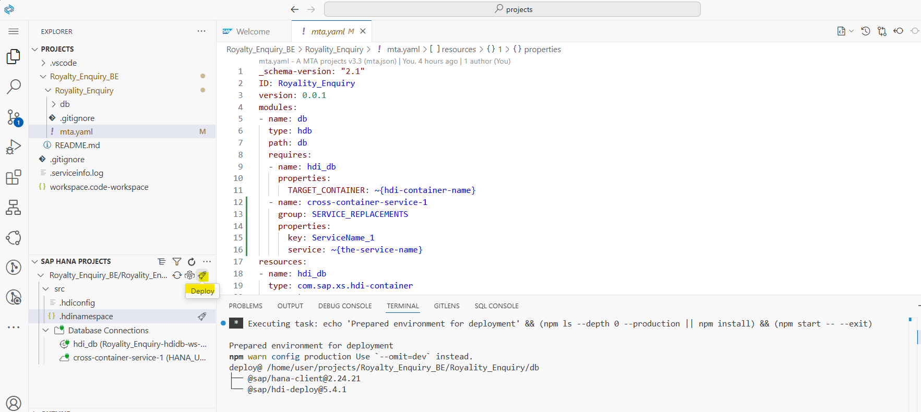
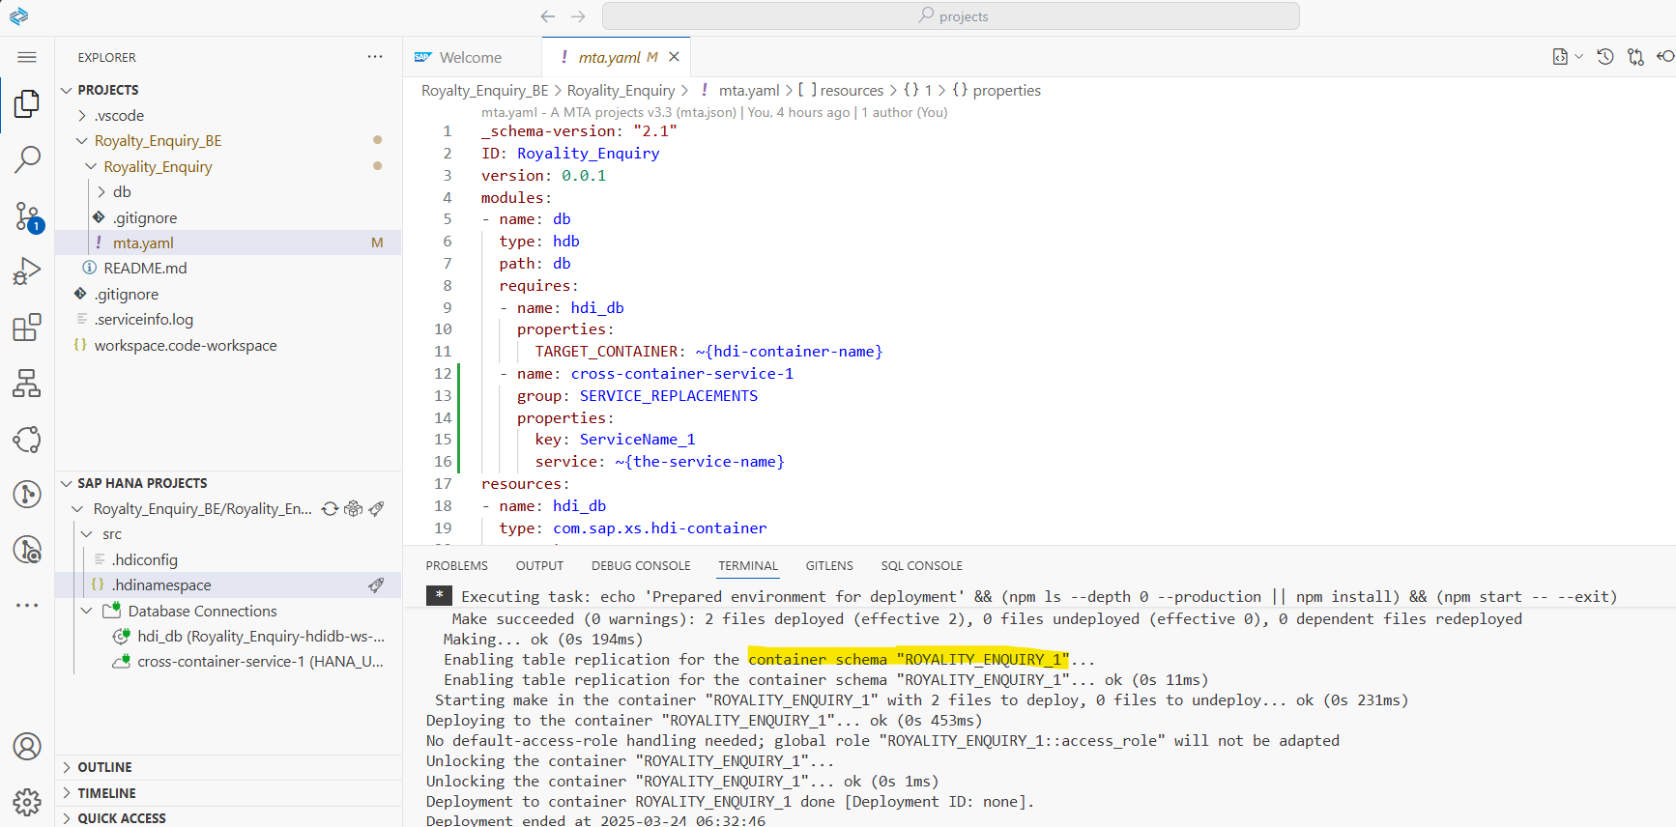
Steps to Synchronize changes from GIT
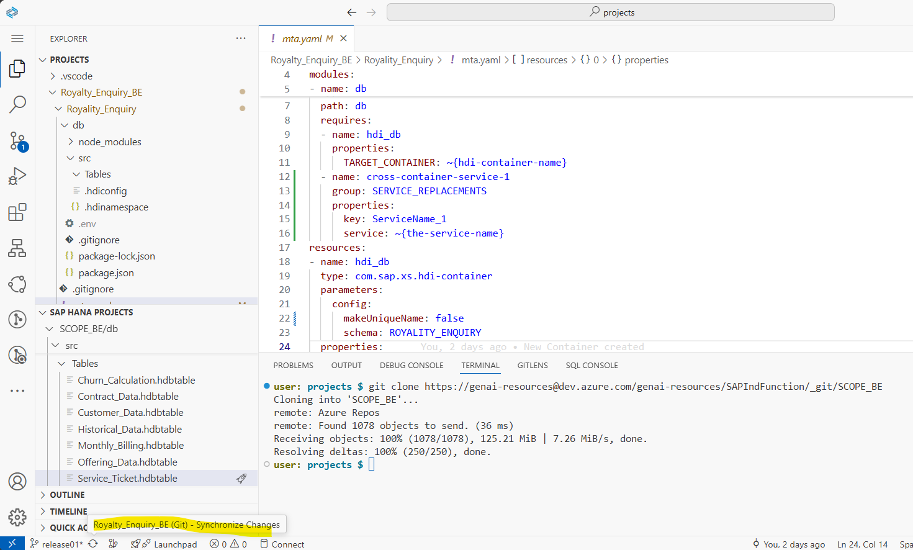

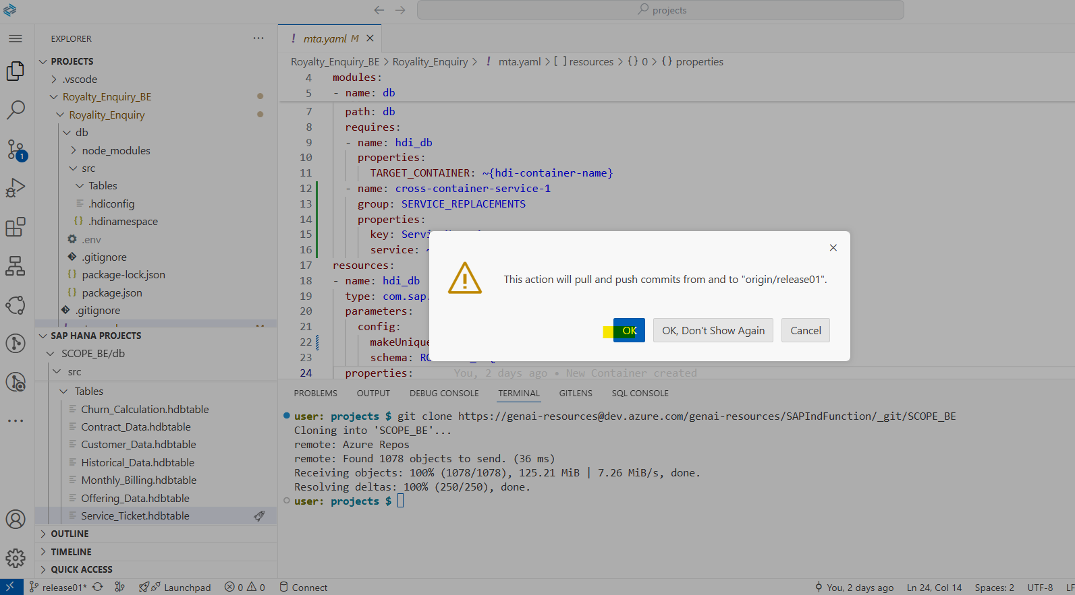
Provide username and password
Steps to create table in BAS

Create table structure from data set that are available
Once done, under db -> src -> create a folder called Tables
To create tables under the folder
Click on Cntrl + Shift + P
Once the Command Palette opens, search for Database Artifacts
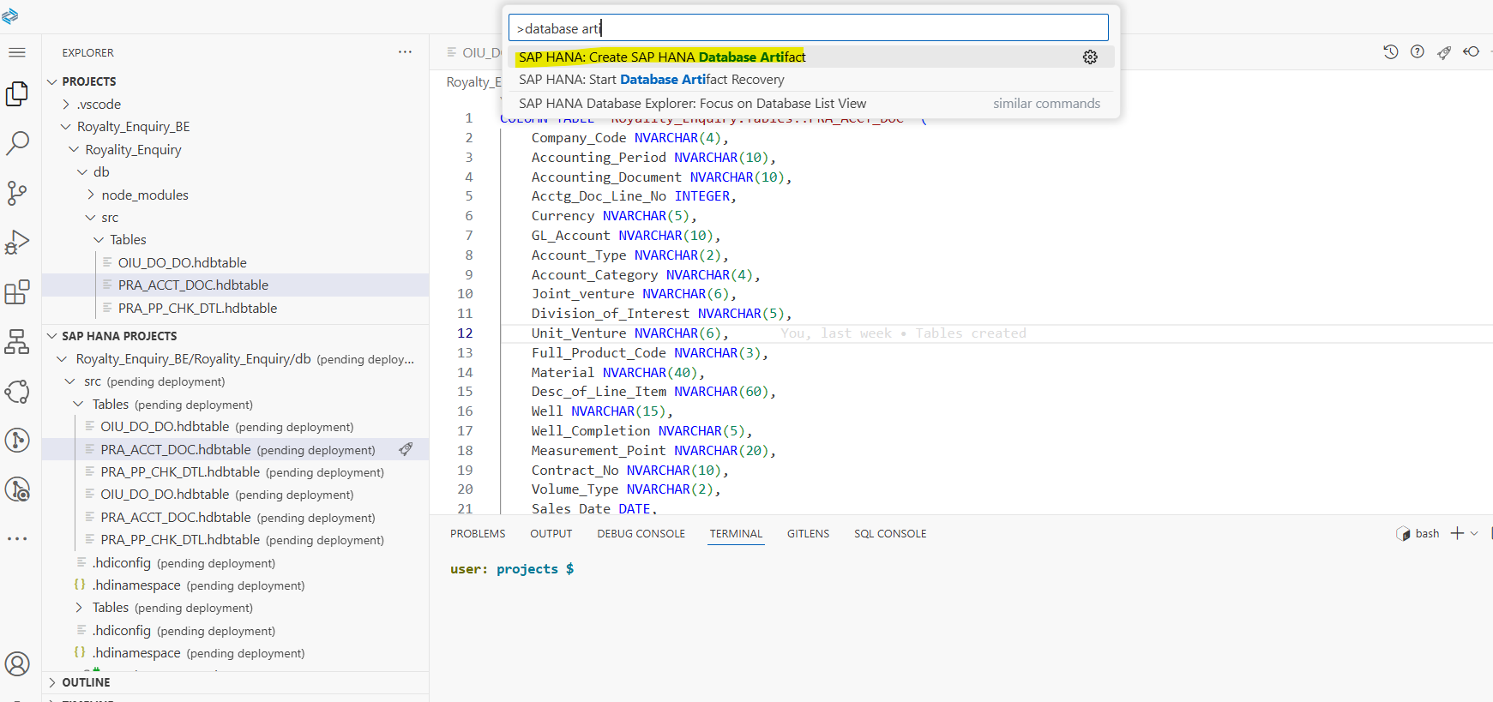
Once selected, choose the folder, artifact type and name the artifact
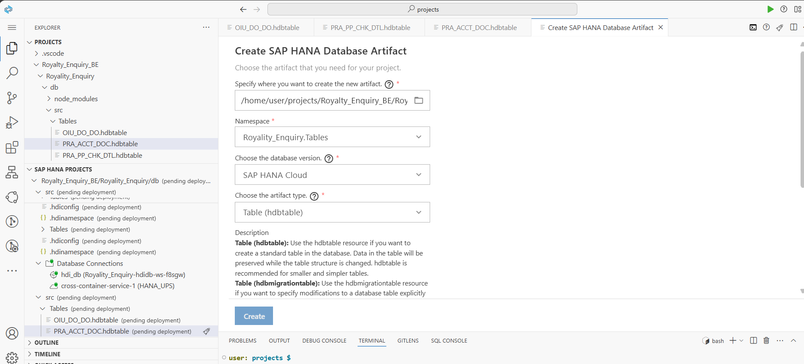
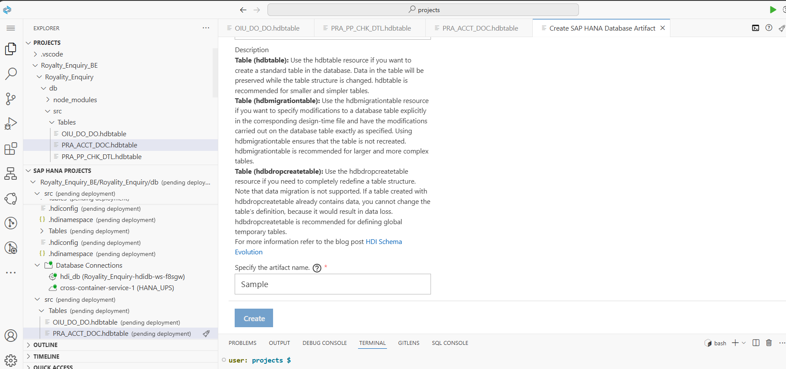
Once table file is generated, the structure can be created as below
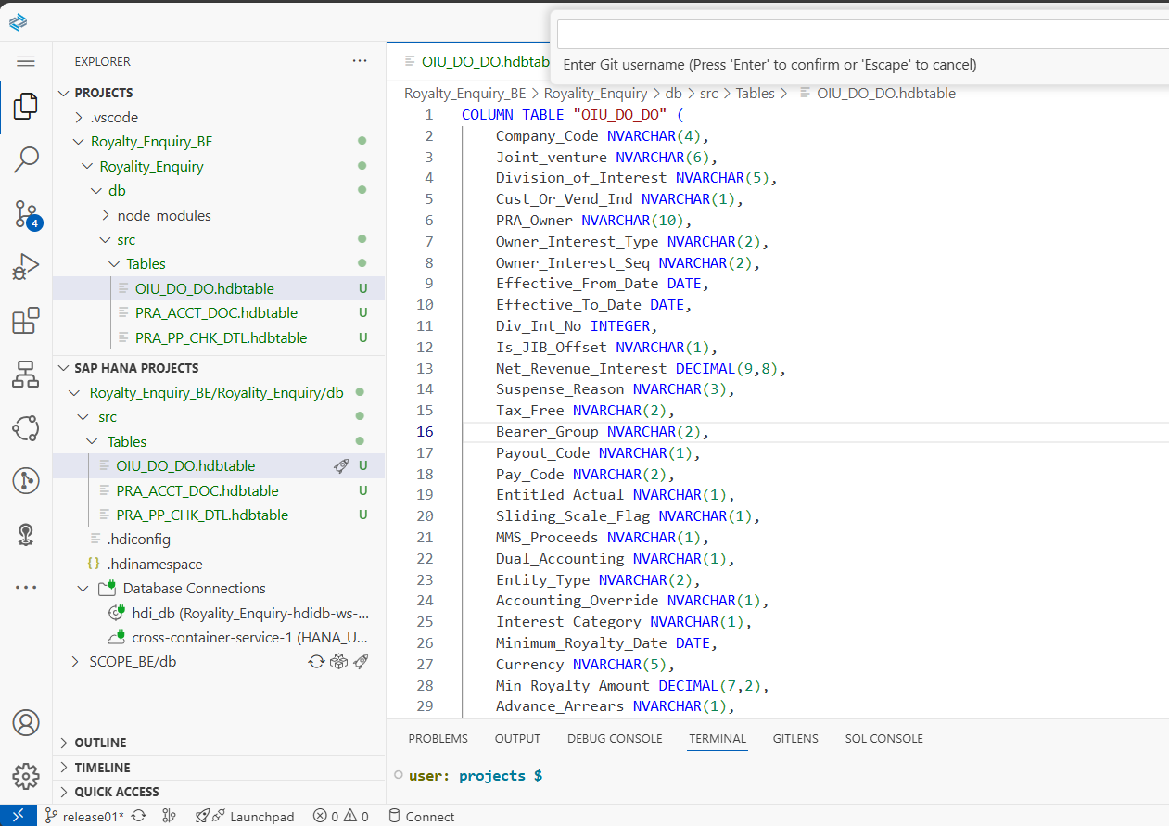

Once created each table can be deployed separately
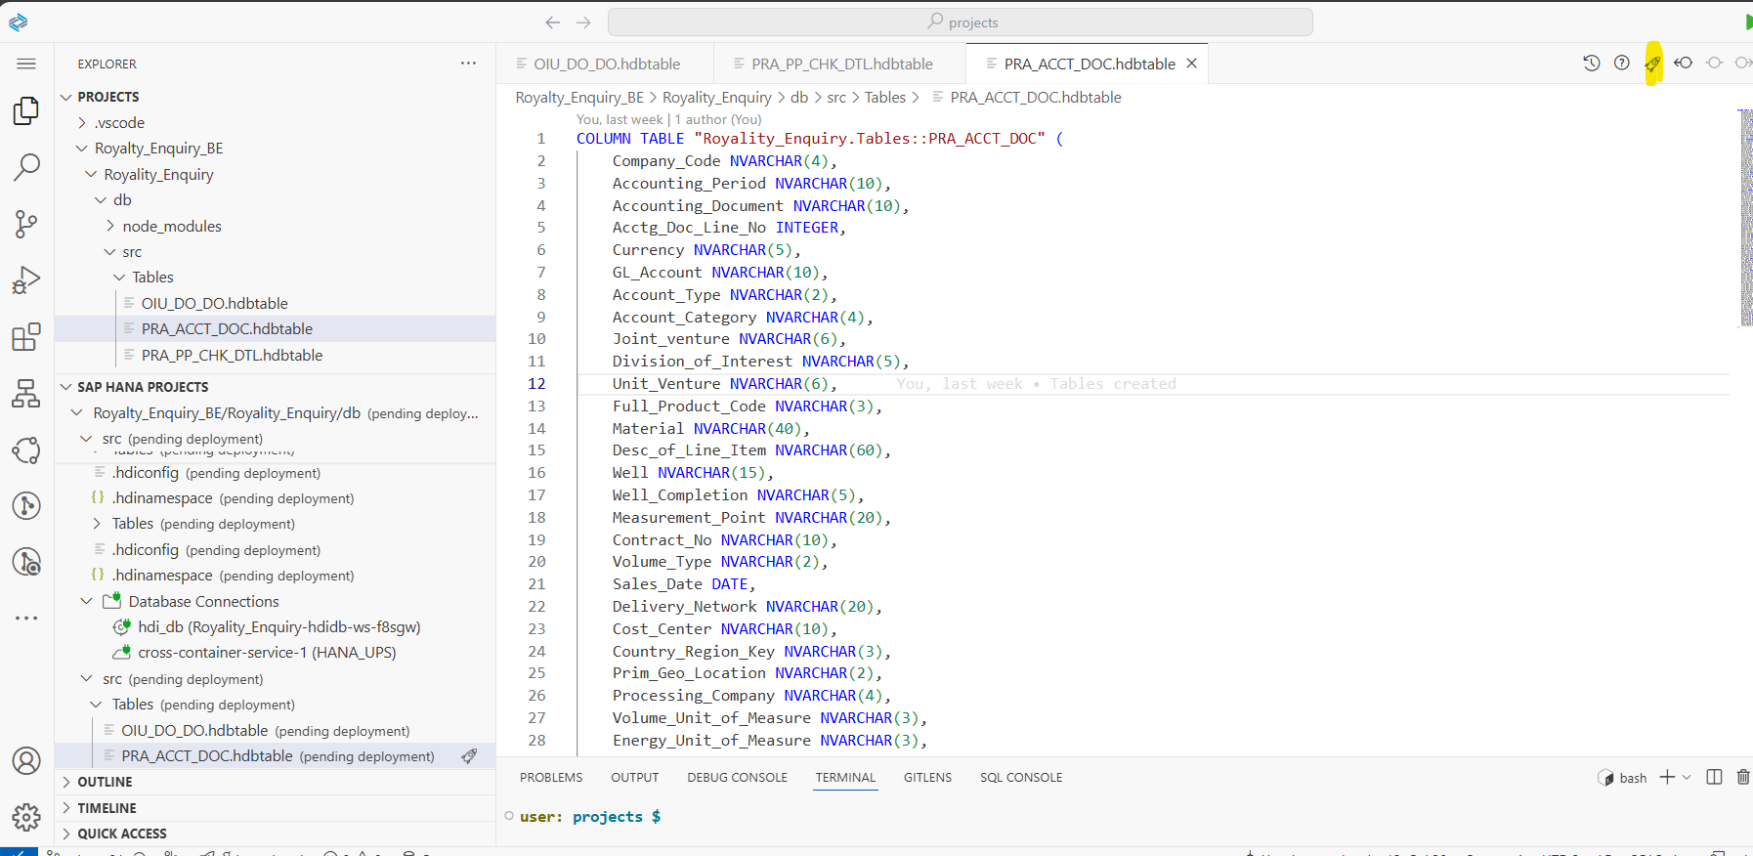

Once deployed commit and push changes to git to get it synced in the repository
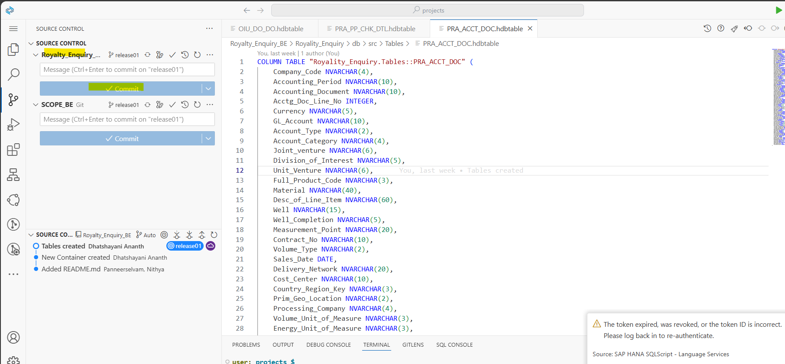

Steps to insert data from DB explorer

Right click on the table that has been created and click on Import data
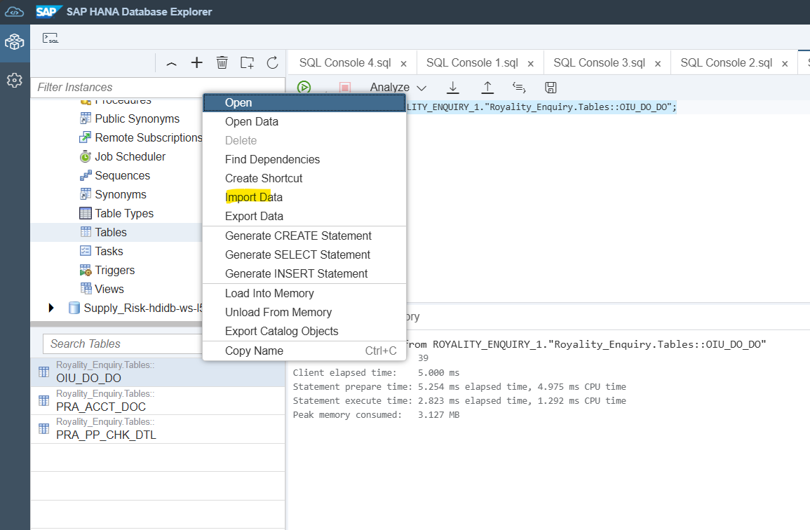

Click on step2
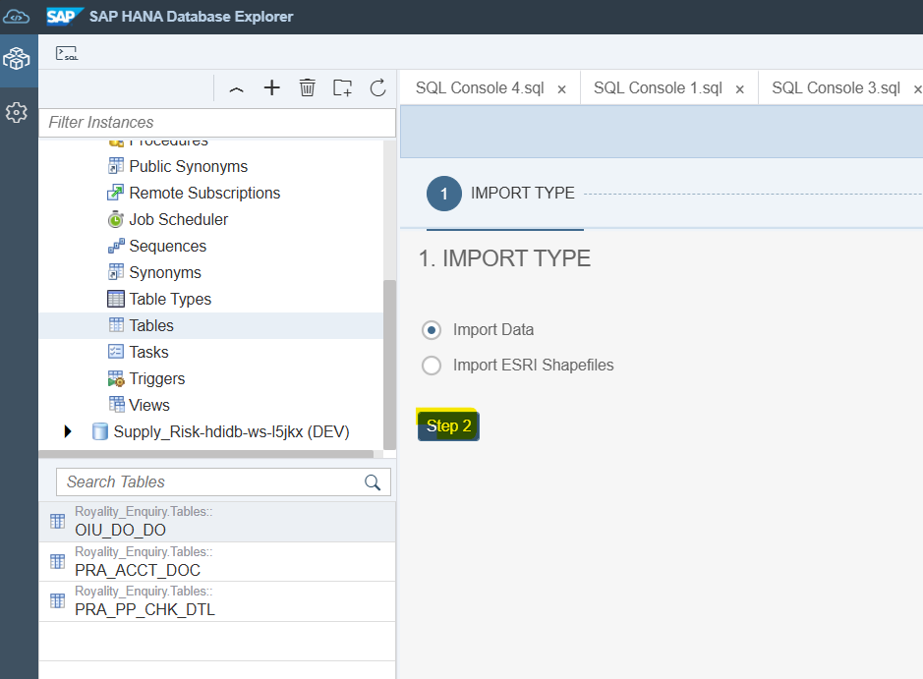

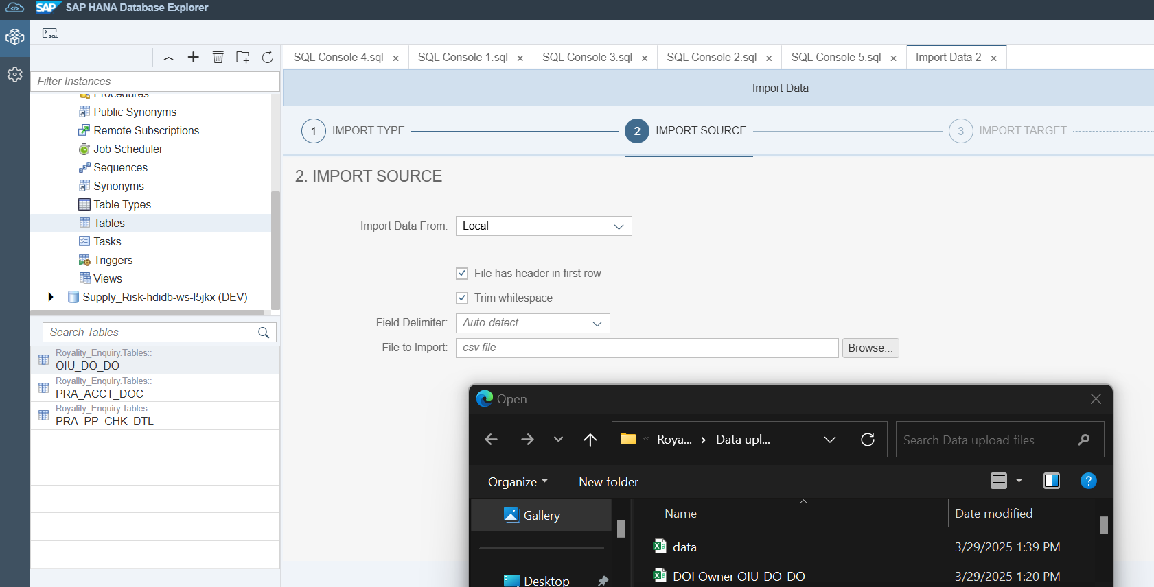
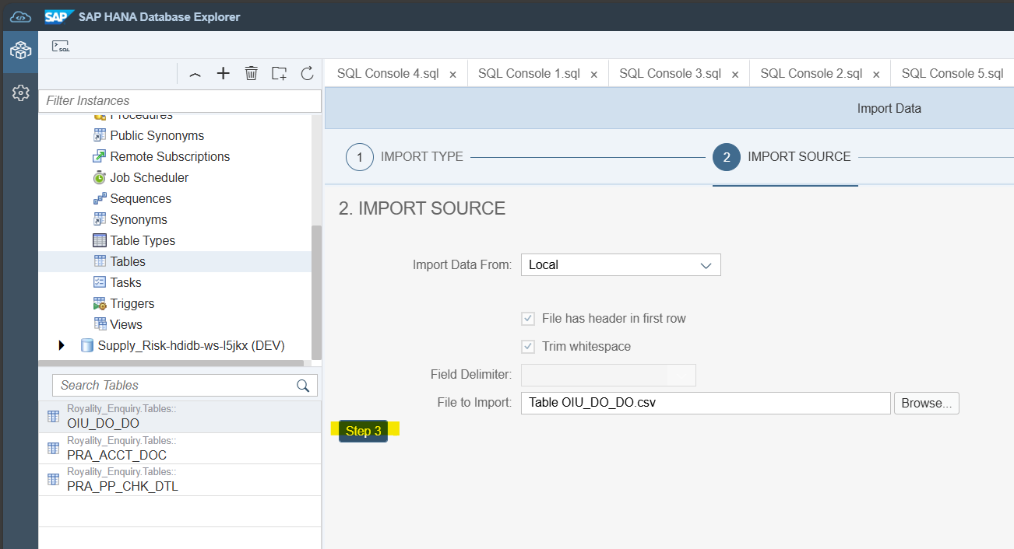
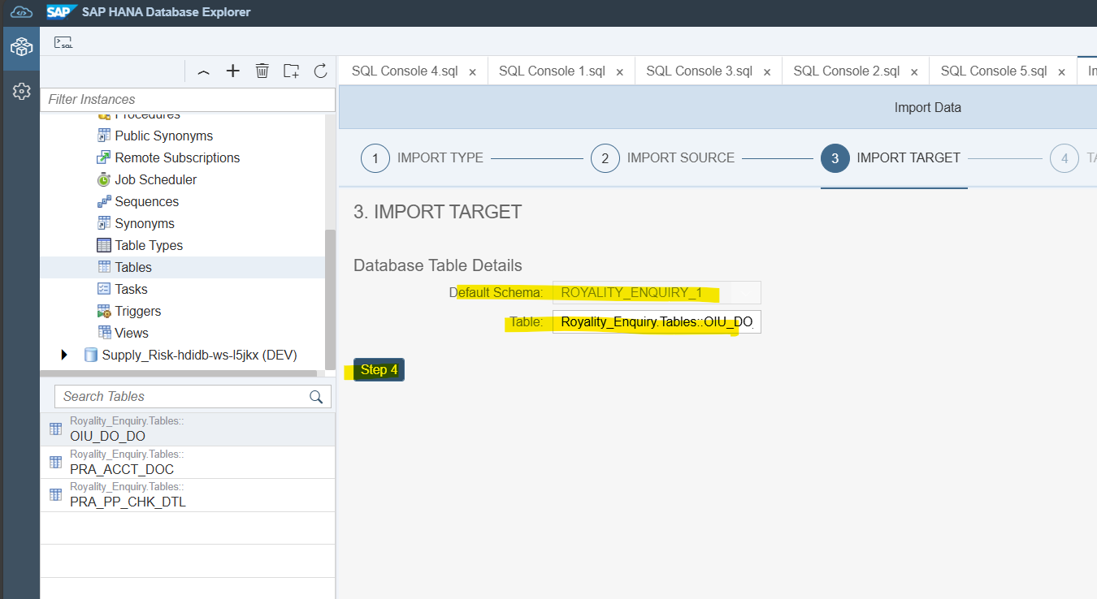
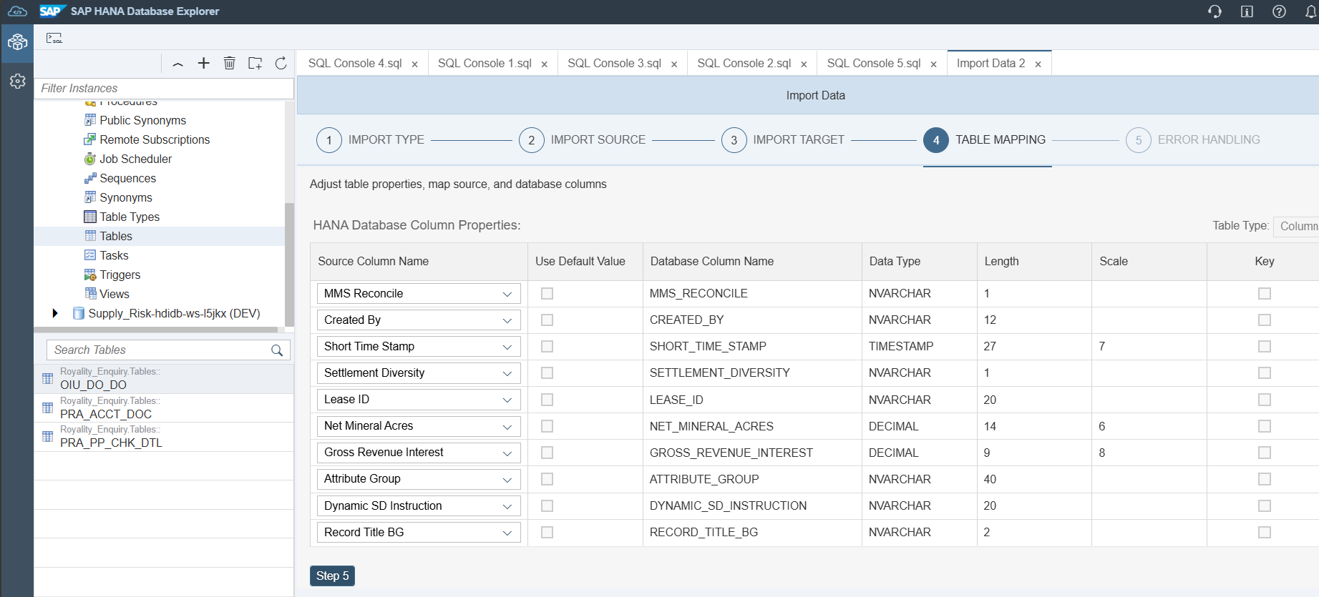
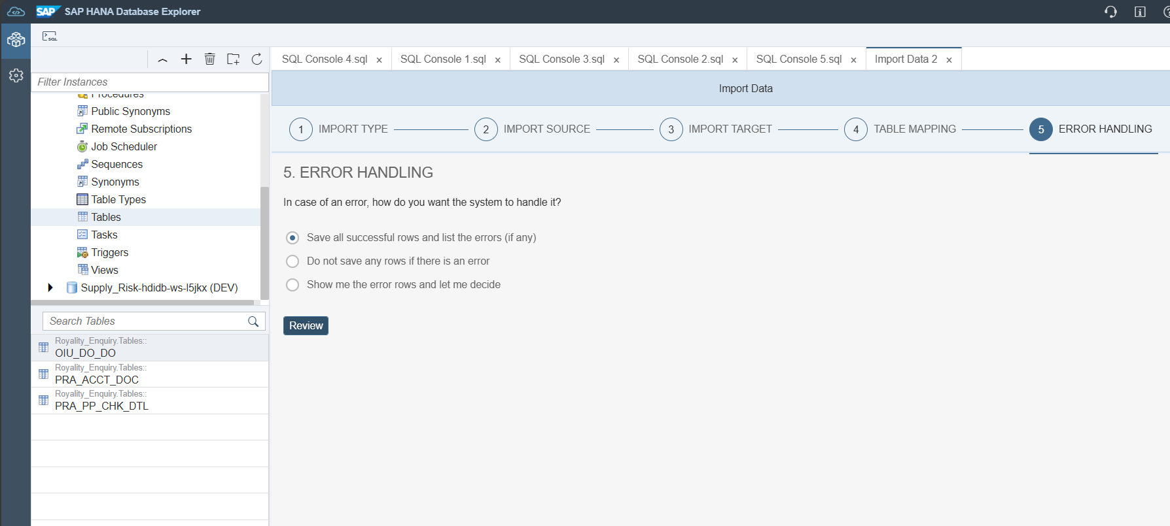
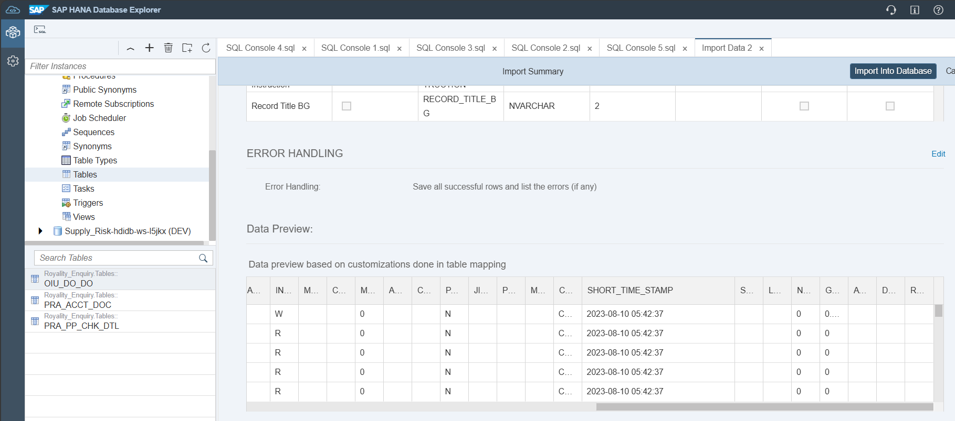
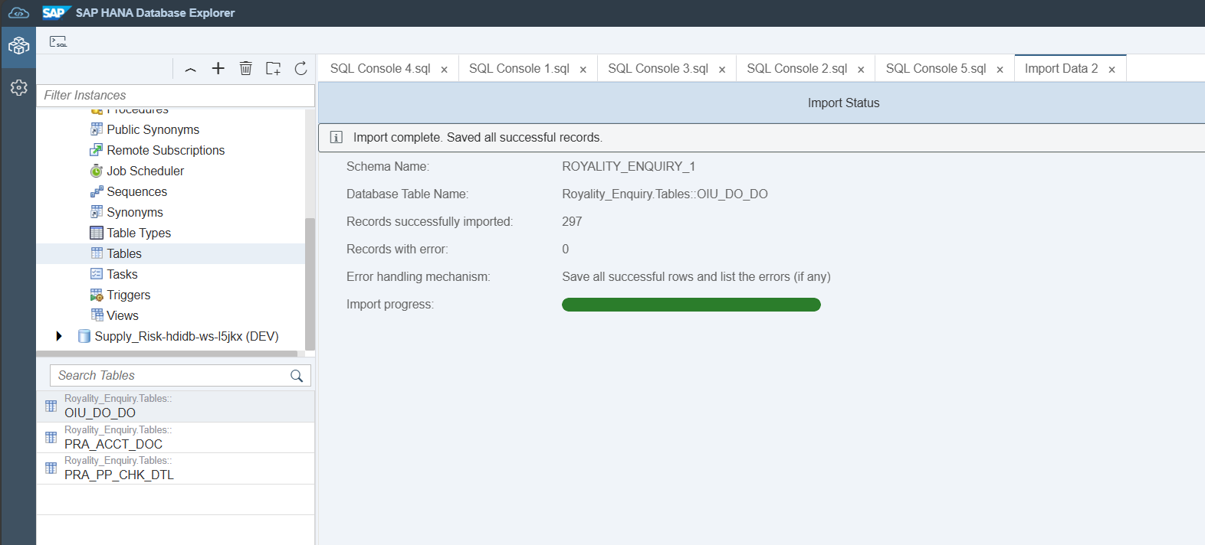

Steps to create virtual tables in BAS
Under db -> src -> create a folder called Virtual_Tables
To create virtual tables under the folder -> Click on Cntrl + Shift + P
Once the Command Palette opens, search for Database Artifacts
Select the path where VT is to be created, choose VT and provide a name for the same
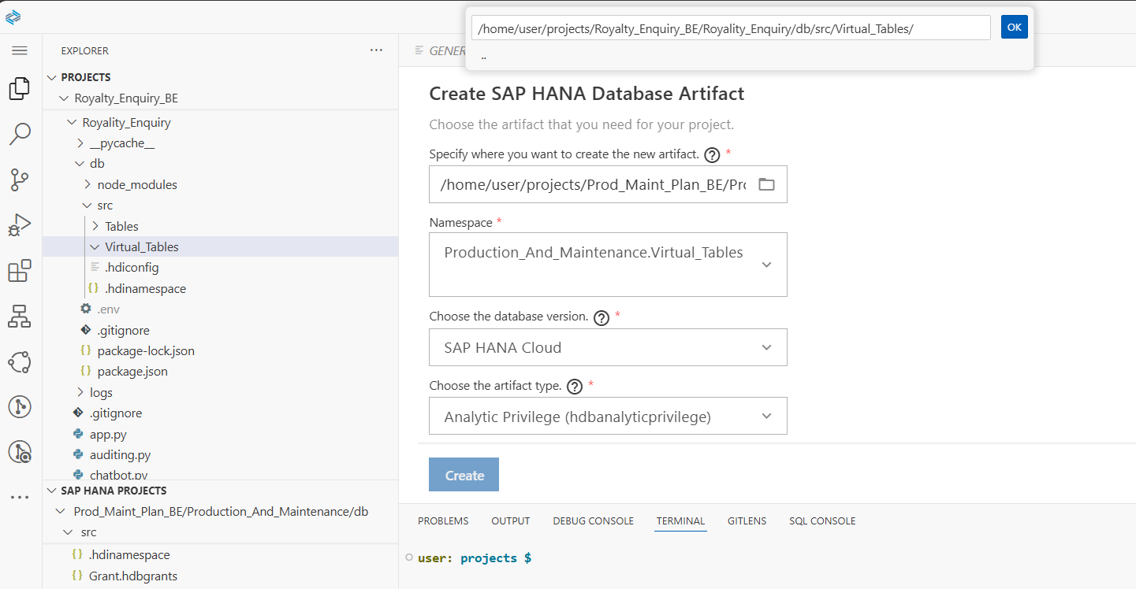
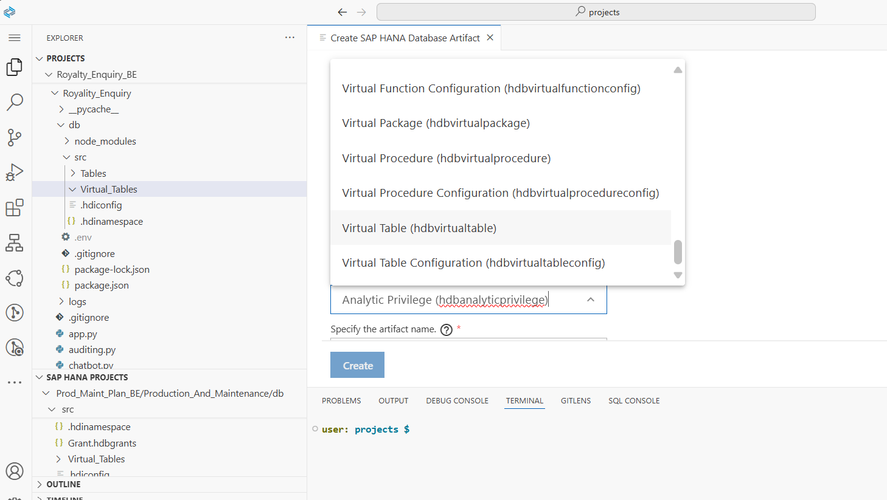
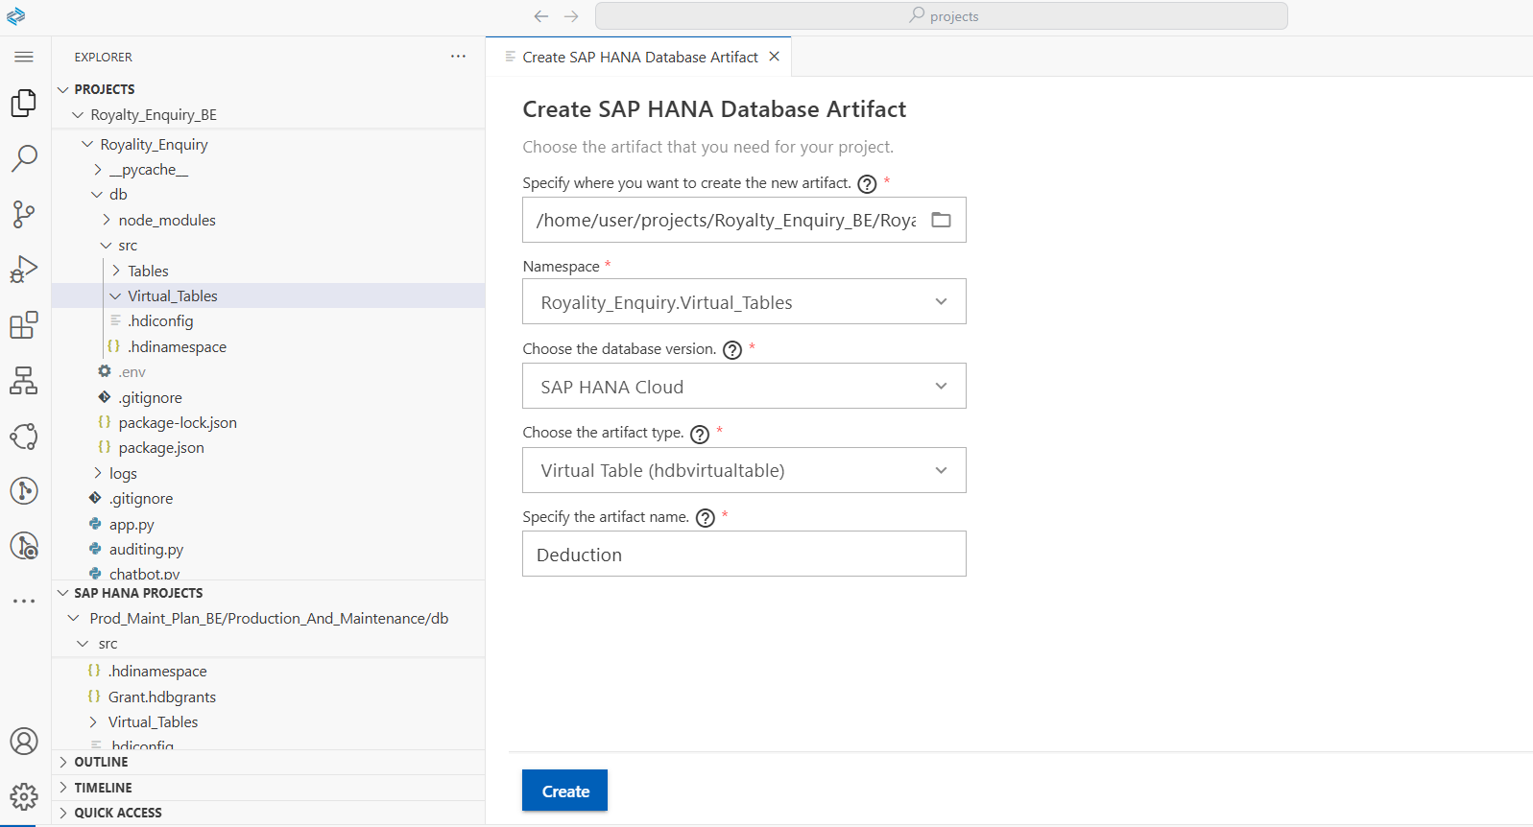
Once VT is created and open it, if you find the below authorization error Grant privilege is to be given to the HANA_UPS user
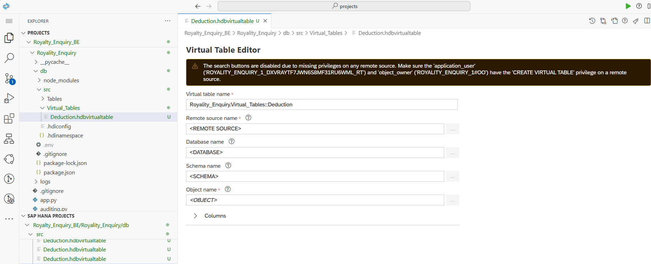

Create a hdbgrants file and deploy the same
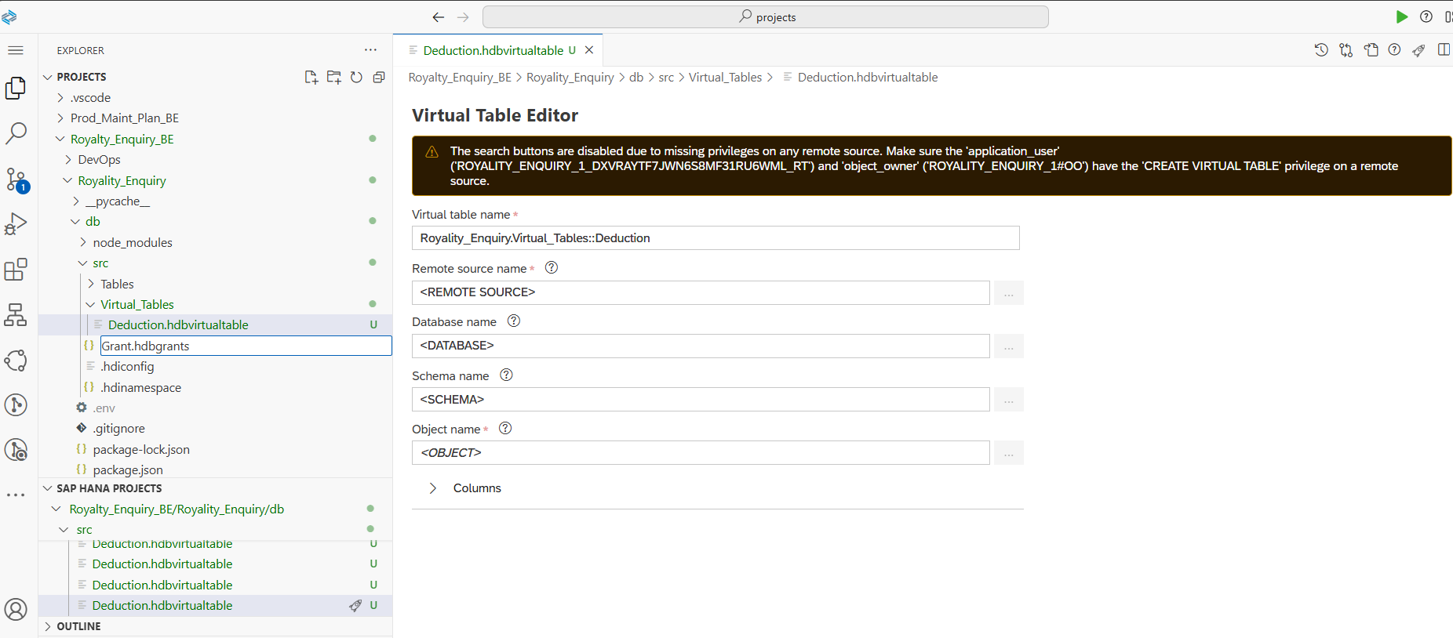

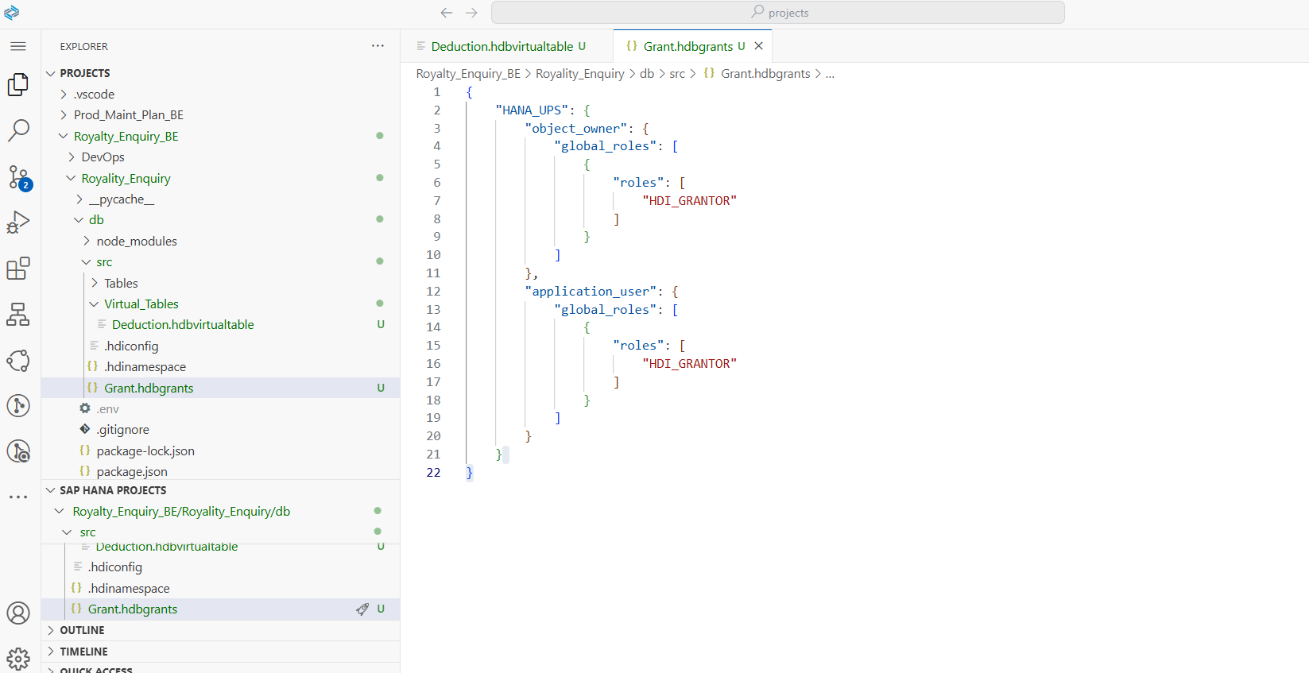

Once deployed, we will be able to select the remote source
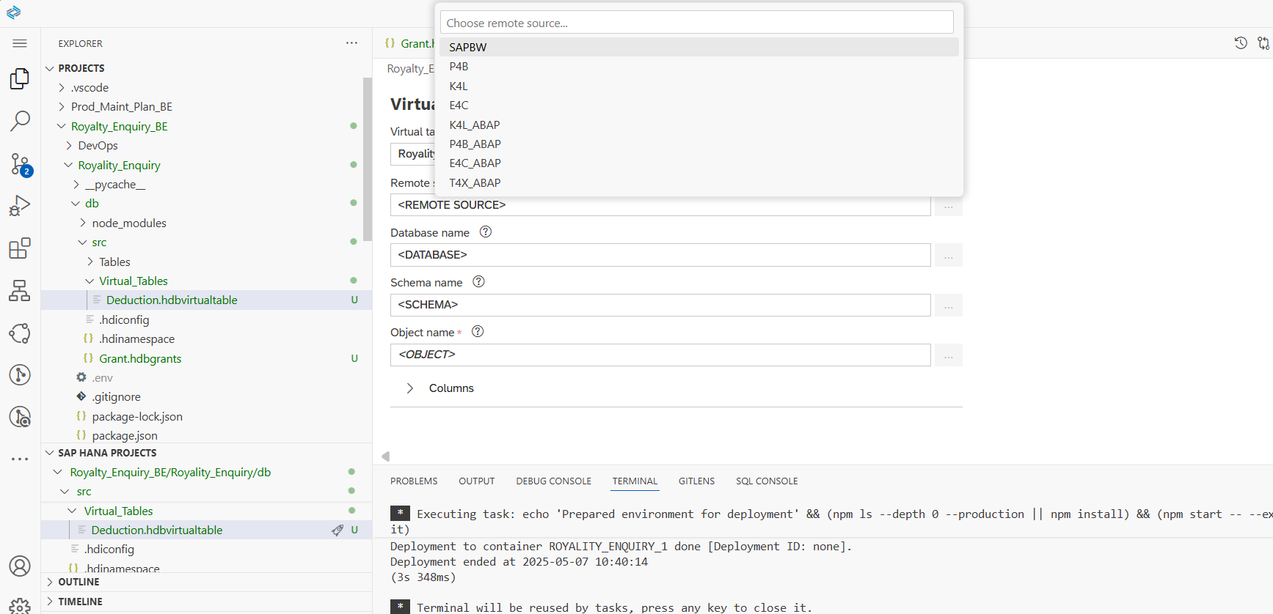
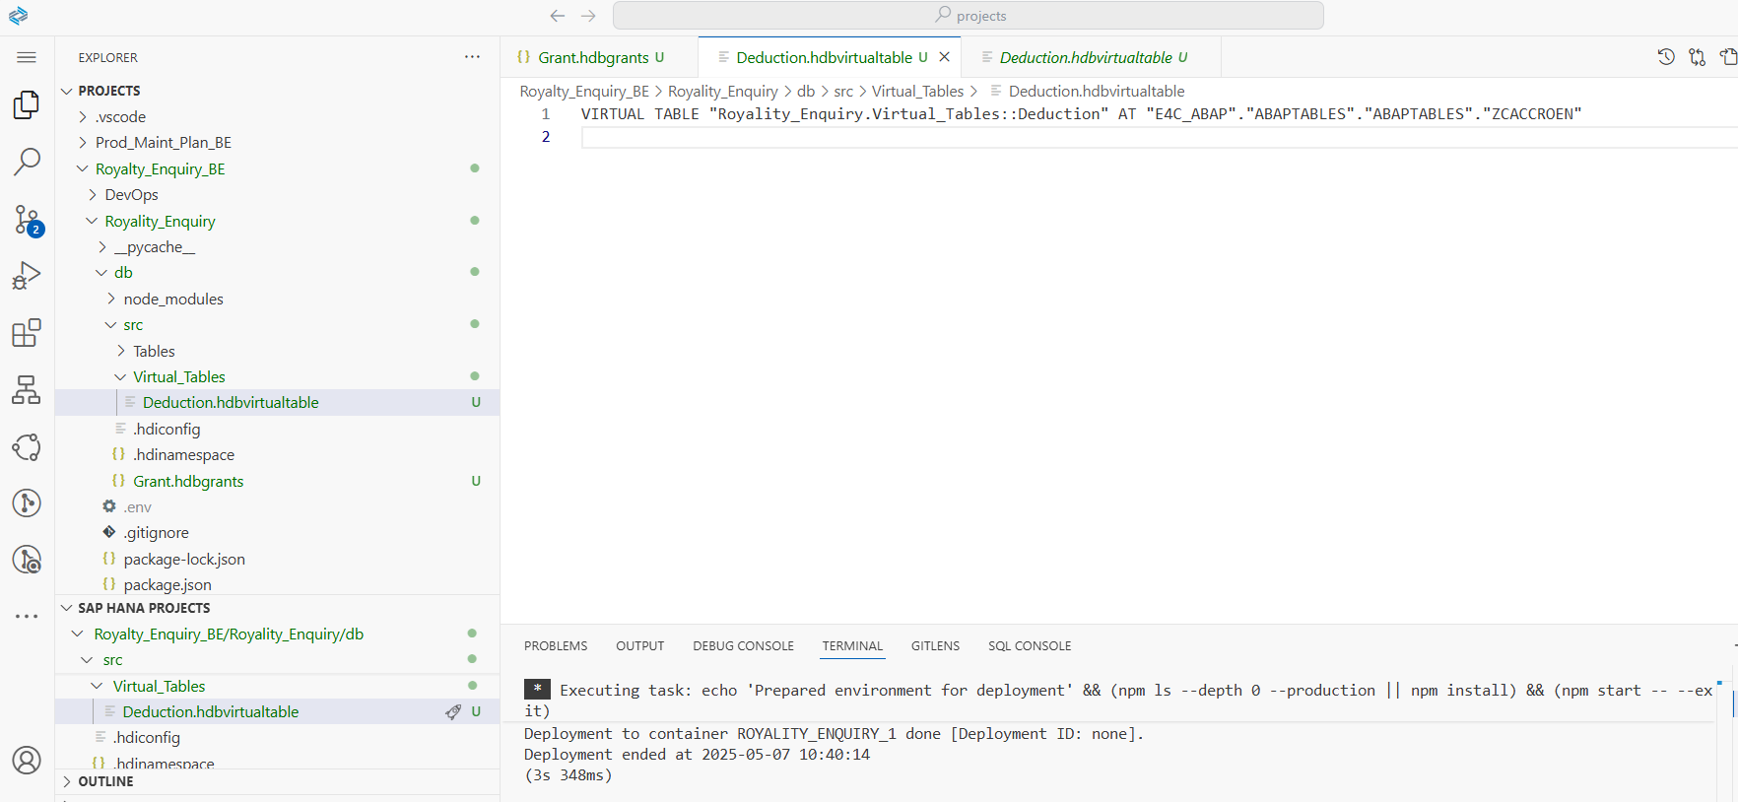

Deploy the virtual table
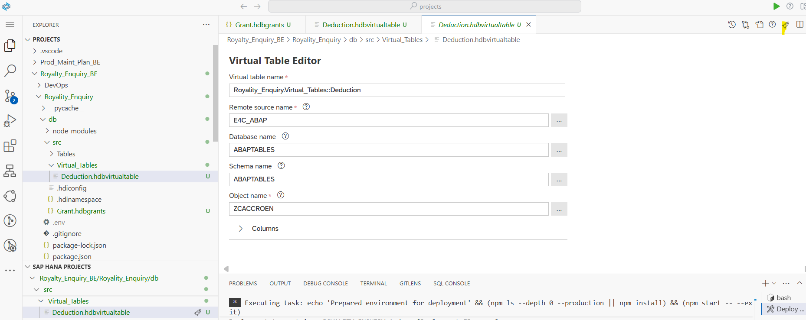
The same can be found under tables section from DB explorer
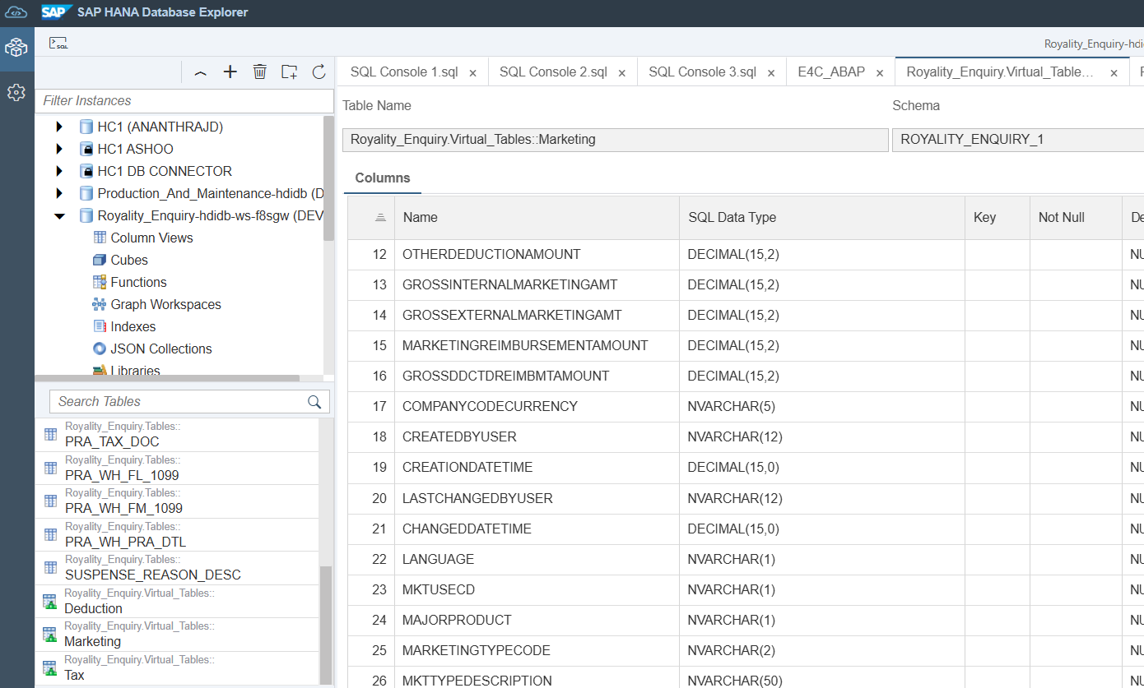
Re deploy virtual tables whenever changes are made from cds end

Possible errors

1] If there is a version mismatch in hdiconfig, update it and deploy
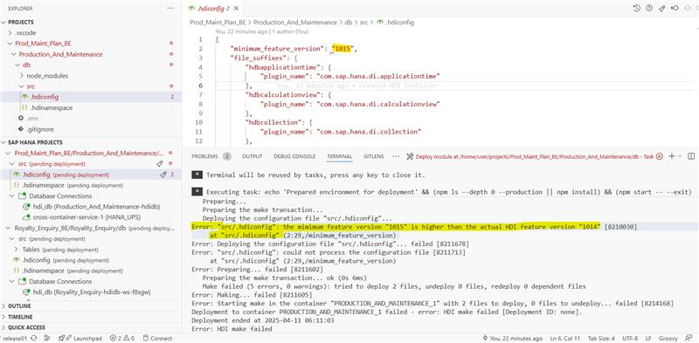

2] Some connection issue, will work after few attempts
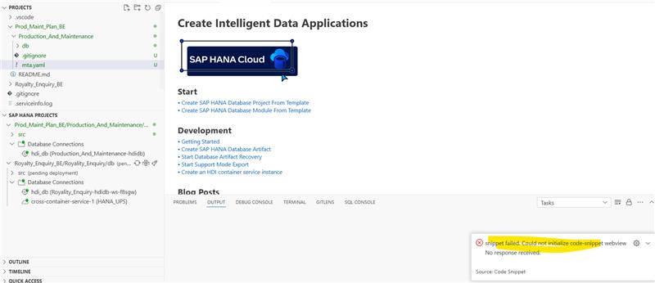

3] Unable to create virtual tables
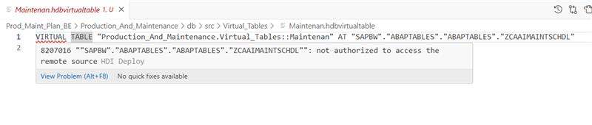
Navigate to BTP cockpit
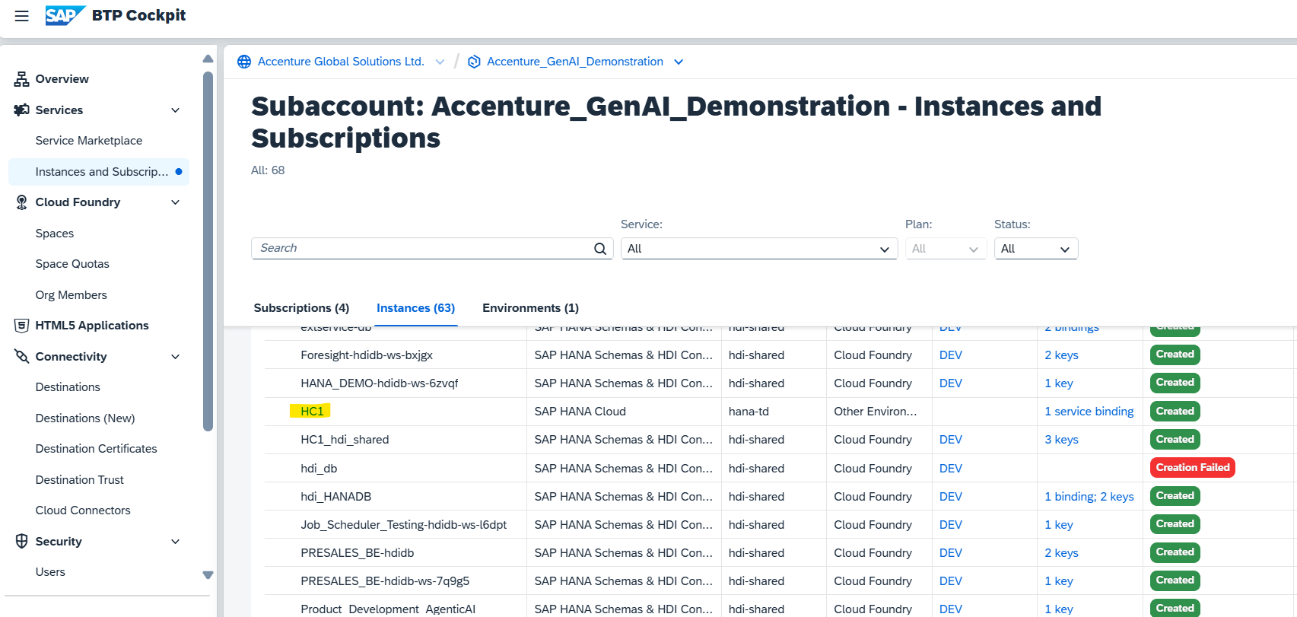

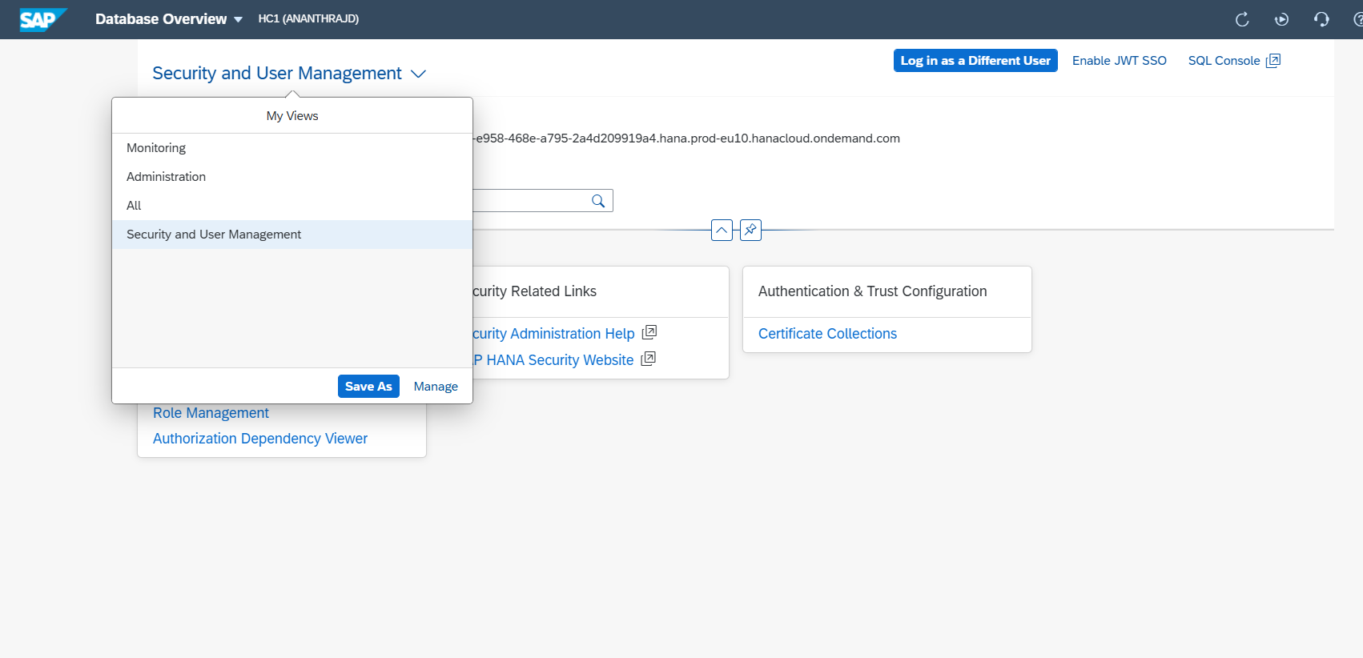
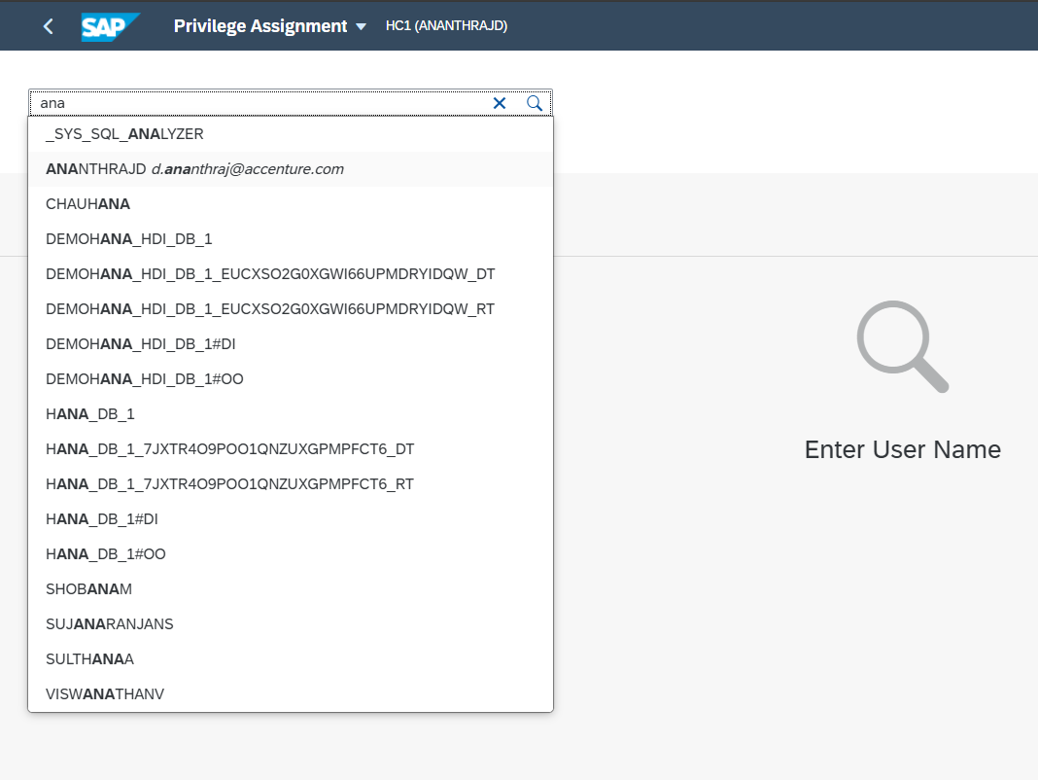
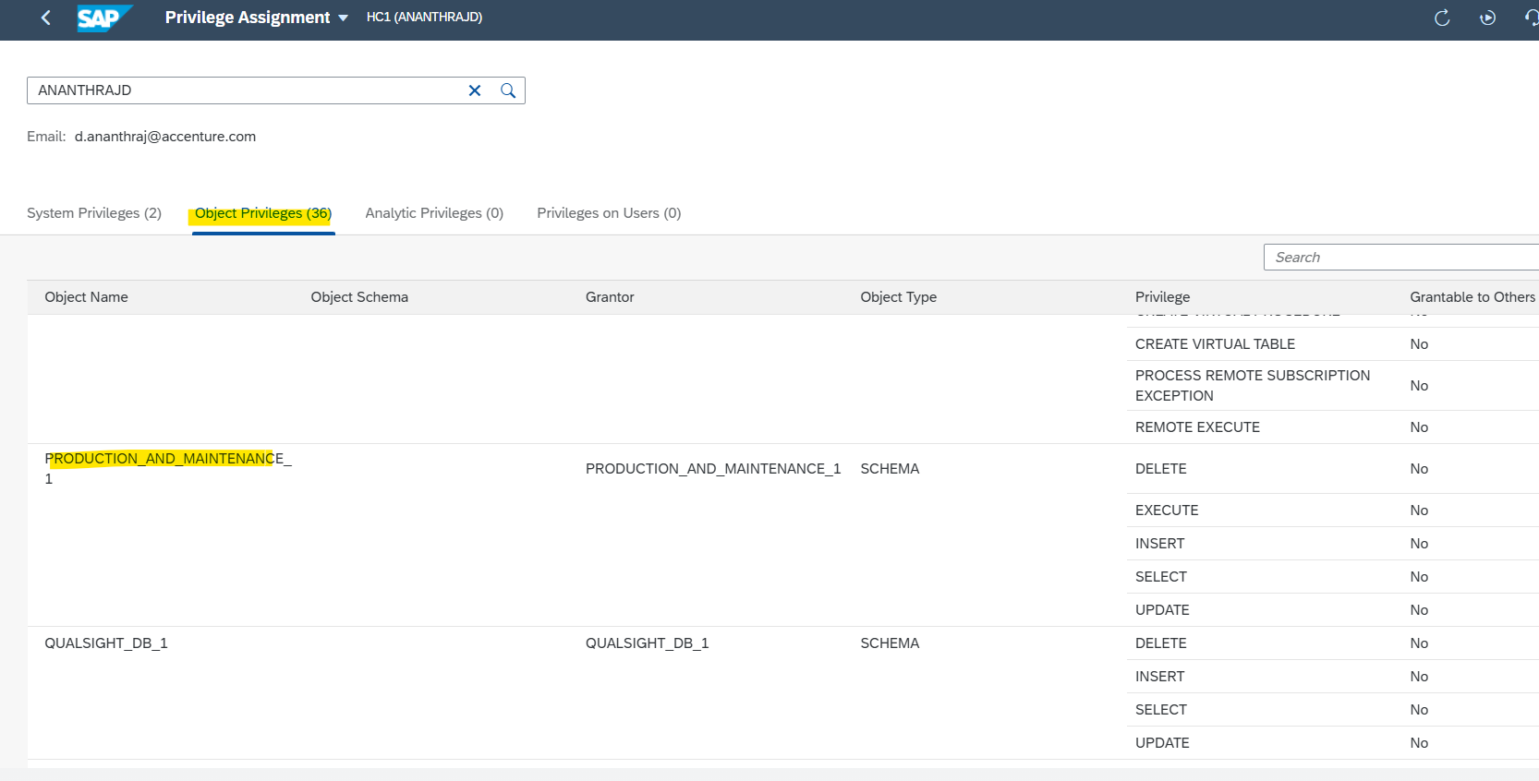

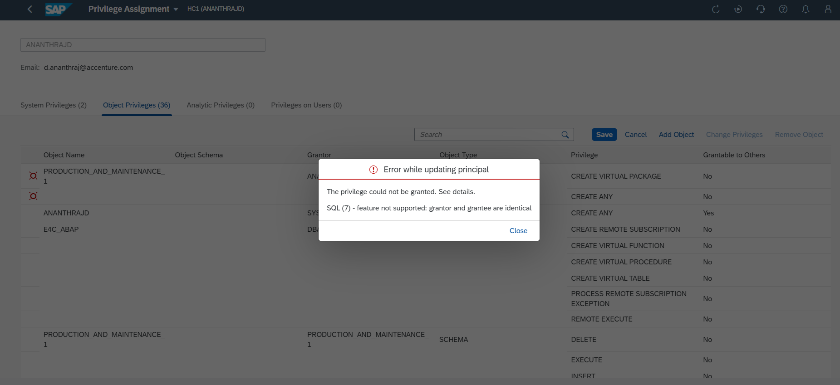
Additional access if required
EXECUTE
SELECT
UPDATE
Grant file
Create grants file to give access to the user (HANA_UPS) for remote source access
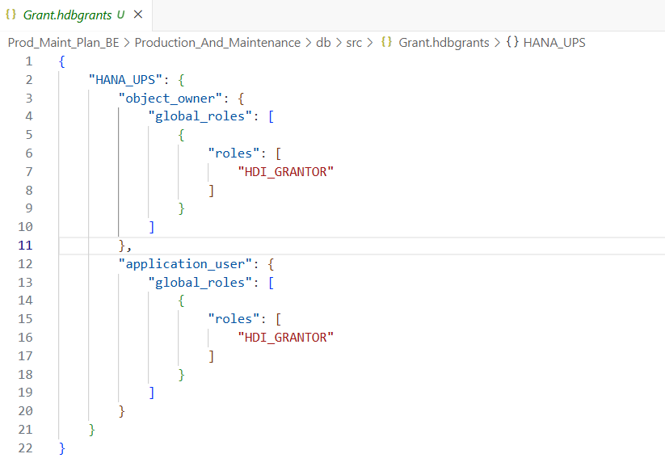
4] Unable to connect to DPAGENT_GENAI
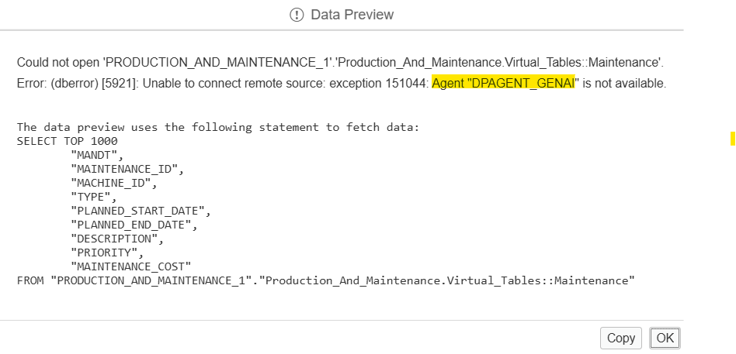

Connection has been interrupted, drop a mail to my concerto team to resolve the same
5] Get access to remote source and then try again
Connect with DB connector and HANA UPS and try again
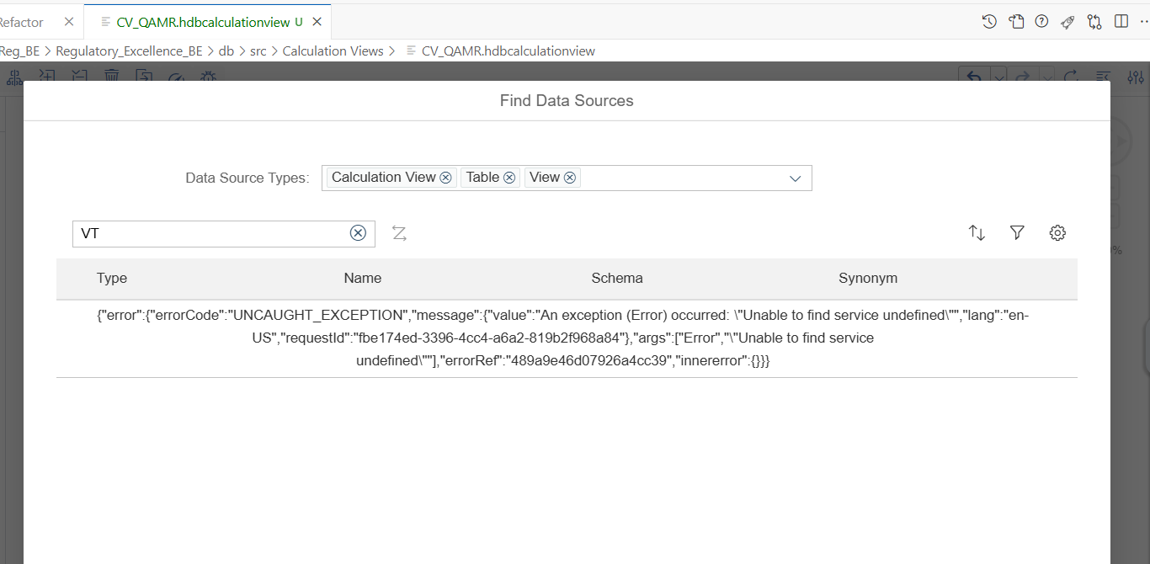
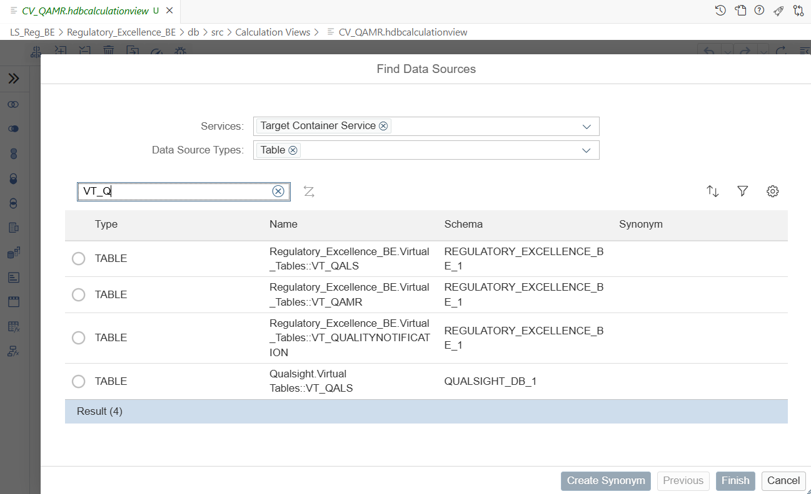

HCI DB Connector

HC1 DB CONNECTOR – this is the common user used by Python folks to access schema from their end and have added login creds to their environment file as configuration setup
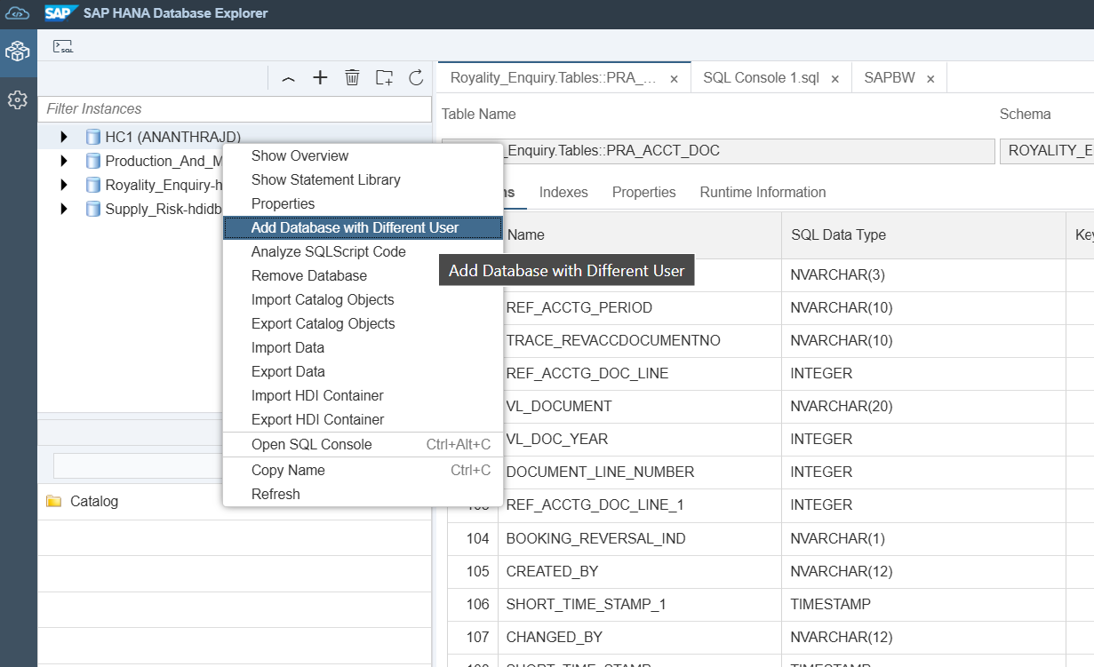
HANA_UNAME="HC1_DB_CONNECTOR"
HANA_PASSWORD="$RUR73b123"
